COMP90007 Internet Technologies
Project 1 – Network Analysis
Student Name: Guancheng Rong
Canvas Login Username: Guancheng R
Student ID: 1856981

Section 2
Ans 2.1
Looking at Fig 2.1.1 and the result achieved in section 2 of the appendix Fig2.1.2

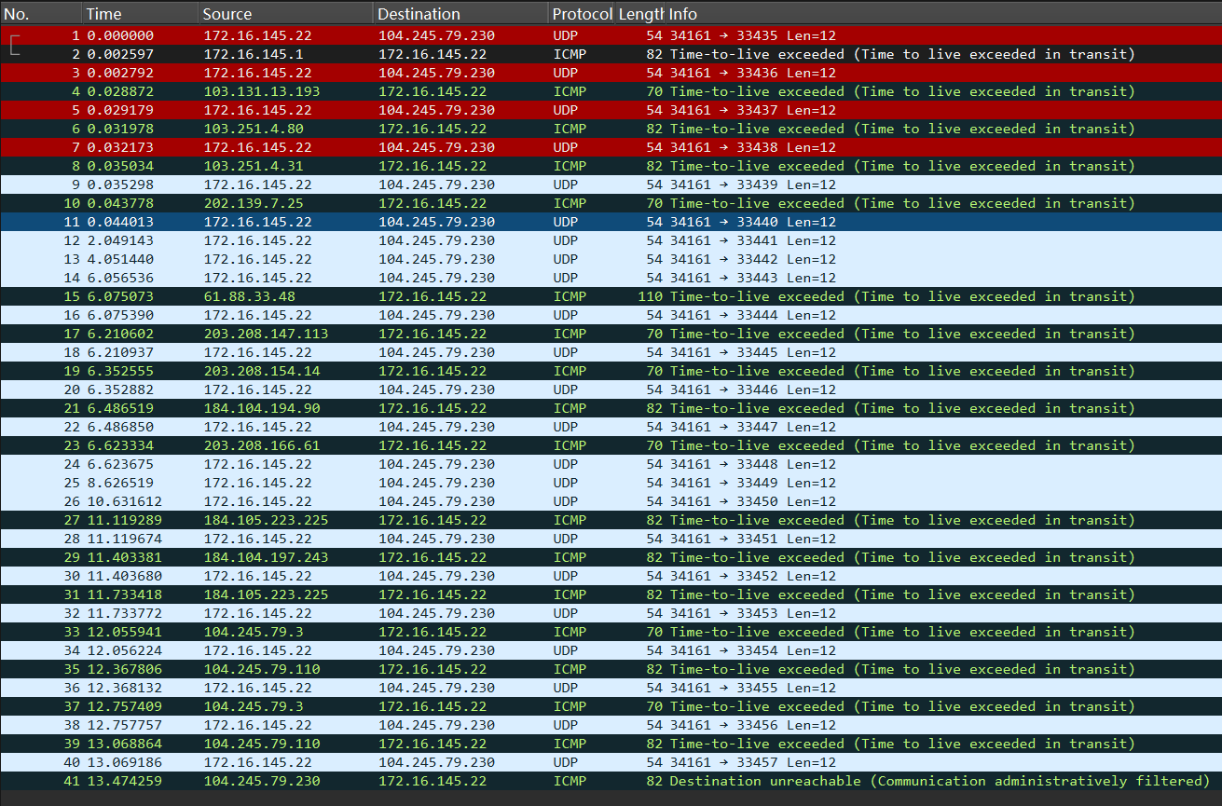
<Fig 2.1.1 Wireshark for one packet from my apartment to speedtest.awbb.net>

Traceroute probes the network path hop-by-hop by sending serialized UDP or ICMP messages with incrementing TTLs to the destination host. It uses the ICMP timeout messages returned by the router when the TTL expires to record the IP address and round-trip delay of each hop.
Therefore, we could use Wireshark to return ICMP protocol to obtain every hop’s IP address. We also can get IP addresses directly from terminal.
My Wireshark capture filter is icmp or (udp and portrange 33434-33534). The first part, ICMP, captures all ICMP protocol packets—this corresponds to the ICMP Time Exceeded message returned by the router during traceroute and the ICMP Destination Unreachable message returned by the final destination. Part 2, UDP and portrange 33434-33534. This port range covers 100 ports after the default starting port 33434 of traceroute, which is sufficient to capture all UDP probe packets in a normal traceroute session. They are sent to the target host in UDP protocol, with the destination port increasing hop by hop starting from 33434.

Will this filter capture non-traceroute traffic?
Yes. The ICMP part is quite broad—it captures not only traceroute-related ICMP Time Exceeded and Destination Unreachable errors, but also any other ICMP traffic. For example, if the user were pinging google.com while capturing packets, those ping ICMP packets will also be captured by this filter.
Similarly, for the UDP and port range 33434-33534, if other applications happen to use UDP communication within this port range.

From the Fig2.1, there are some information about the first 5 hops and last hop.
1st 172.16.145.1 TTL (Time-to-live) = 1
2nd 103.131.13.193 TTL = 2
3rd 103.251.4.80 TTL = 3
4th 103.251.4.31 TTL = 4
5th 202.139.7.25 TTL = 5
The last 104.245.79.230 TTL = 23
We will analyse the 6 hops line by line.
The first hop is 172.16.145.1. It shows that the packet was sent to the private network gateway which is the student apartment IP address.
The second hop is 103.131.13.193. According to section 2 of the appendix Fig2.1.3, We could search from https://db-ip.com/ and find it belongs to Melbourne, [1] which maybe Metropolitan Area Network. This time’s RTT is high up to 26.332ms, which means that the packet was transmitted to the local central network gateway.
The third hop is 103.251.4.80. According to section 2 of the appendix Fig2.1.4, We could search from https://db-ip.com/ and find it belongs to Sydney.[1] Meanwhile, the RTT is quite low which means that we still send messages to the Australia network gateway.
The fourth hop is 103.251.4.31. According to section 2 of the appendix Fig2.1.5, We could search from https://db-ip.com/ and find it belongs to Sydney. [1] Similarly, the RTT indicates that we still send messages to the Australia network gateway. Meanwhile, the IP address there is a difference only in the last byte, which means that both belong to one ISP.
The fifth hop is 202.139.7.25. According to section 2 of the appendix Fig2.1.6, We could search from https://db-ip.com/ and find it belongs to Sydney. [1] However, in this case, the RTT suddenly increased significantly from 3ms to 8ms, which may mean the network is preparing for the international transmission. The packet arrived at the peering point. Then, the following traceroute, there are 3 following hops exceed time which is also proving that the result.
In summary, until the fifth hop, all RTT is under 9ms, which is low compared with the future RTT. We could know until now that we still send the ICMP messages in Australia.
The last hop is 104.245.79.230. We can see it in Wireshark. There is one info which shows Destination unreachable. This means our request has reached the destination. No matter whether it’s reachable or not, it’s the IP address of speedtest.awbb.net. According to RTT number, we could easily know we sent the ICMP message to one international network gateway.

.

Ans 2.2
It continues section 2 of the appendix Fig 2.2.4~Fig 2.2.13[1]
I choose the iperf.he.net as the 10th server which is in California, USA.
We could get the latitude and longitude of the ten servers. And there are some interesting finds. Firstly, the third server (speedtest.wobcom.de) in Austria is actually in Germany [1] and in the same city which has 2nd server (spd-desrv.hostkey.com). Then, the 7th server is listed in Porto, Portugal, but it locates in Lisbon in fact. [1] The last some server can’t use UDP traceroute mode, therefore ICMP traceroute mode is an available alternative.

And then, I used one algorithm to calculate the distance between each server and Melbourne. The great-circle distances between Melbourne and each destination were computed using the spherical law of cosines formulation of the Haversine distance (Sinnott, 1984), with a mean Earth radius of 6371.[2] According to Fig 2.2 in section 2 of appendix, destinations’ latitude and longitude come from the https://db-ip.com/.[1]Depending on a python calculator – Fig 2.2.3 in appendix for section 2, we can get the result of the distance.
The distance between two points on the Earth's surface (assumed spherical) is computed with the Haversine spherical law of cosines formula:[2]
d = R * arccos * (sin(φ₁) * sin(φ₂) + cos(φ₁) * cos(φ₂) * cos (λ₂ − λ₁))
φ₁, λ₁ | Latitude and longitude origin (Melbourne)
φ₂, λ₂ | Latitude and longitude destination
There is one interesting find that except the 10th server I choose by myself, the farthest server is 7th server(porto.speedtest.net.zon.pt) and the closest server is 8th server(speedtest.masnet.ec). The two server we will use in the section 4.

And make a summary -- Fig 2.2.1
<Fig 2.2.1 the summary for 10 iperf servers >

Therefore, we could use the table to make A scatter chart of the hop count versus the approximate geographical distance from Melbourne.

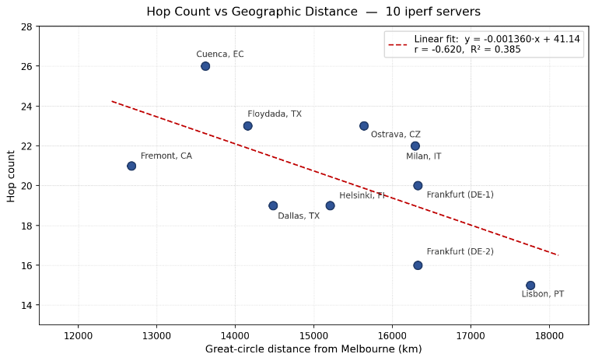
<Fig 2.2.2(a) A scatter chart of the hop count versus the approximate geographical distance from Melbourne >
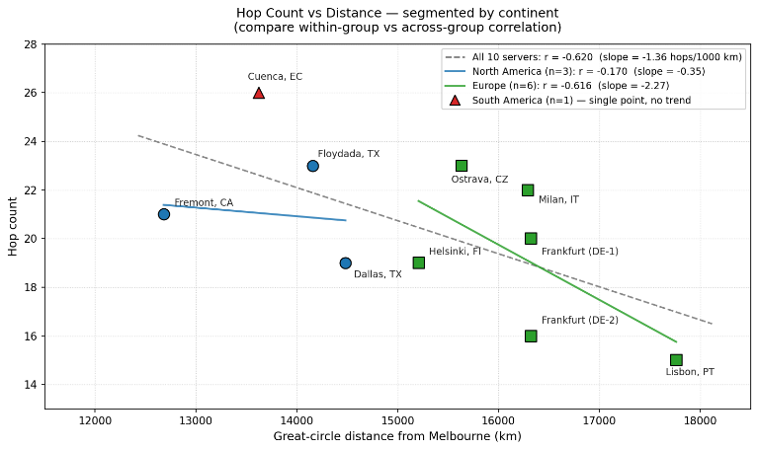
<Fig 2.2.2(b) A scatter chart by continent>
From Fig 2.2.2(a), we could easily find the R² = 0.385 and r = -0.620. The linear fit: y = -0.01360*x + 41.14. When the distance is increasing, the hop count is falling.
We could know the relationship between hop count and Geographic Distance is negative correlation.
There are two major reasons:
1. Long-distance routes often utilize large backbone networks. These backbone networks have high routing optimization and fewer hops. Short-distance routes, on the other hand, may involve peering through multiple smaller ISPs, increasing the hop count with each peering. For example, in our diagram, the distance between Cuenca and Ecuador is only ~13,500km, but the hop count is as high as 26, indicating that the route to South America passes through many intermediate networks.
2. We could know that Hop count reflects network topological distance, not geographical distance. Two geographically distant nodes directly connected by the same submarine fibre optic cable may have a low hop count; conversely, geographically close nodes that traverse multiple Autonomous Systems (AS) will have a high hop count. [3, p.396]
From Fig 2.2.2(b), when we divided the chart by continents, we could find that the six servers in Europe showed a strong negative correlation (r = -0.616), while the three servers in North America showed almost no correlation (r = -0.170). This indicates that the strength of the correlation depends on whether the routing paths share a similar backbone network structure.

Section 3
Ans 3.1

Looking at Fig 3.1.1 and the result achieved in section 3 of the appendix Fig 3.1.2
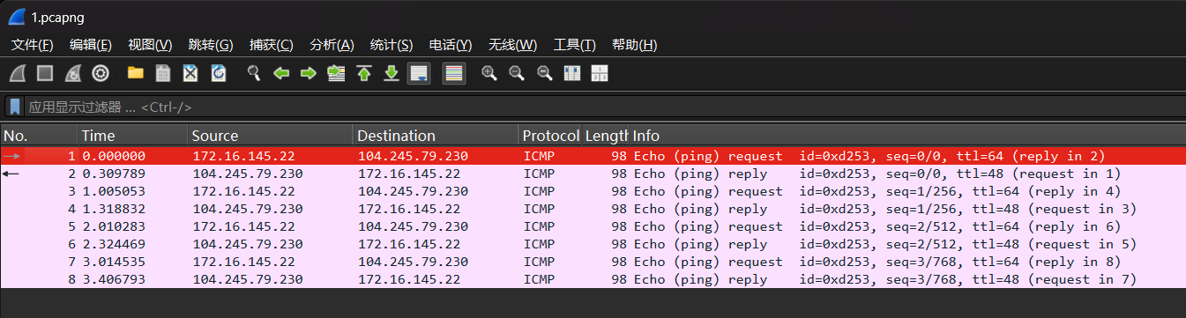
< Fig 3.1.1 Wireshark for ping speedtest.awbb.net>
Looking at Fig 3.1.1, my machine sends 4 ICMP echo request (type: Echo (ping) request (8), code: 0) to the destination, we could see them in the picture – No.1, No.3, No.5, No.7. The destination will send ping reply (type: Echo (ping) reply (0), code: 0). The original TTL is 64 and the reply TTL is 48, which means that the packets traverses 64 – 48 = 16 hops. And we can see that all ICMP id is 0xd253 which indicates the 4 request and 4 reply belong to one time ping command.
Turn to Fig 3.1.2, the data bytes from speedtest.awbb.net is 56 bytes. However, each packet was transmitted 64 bytes, because ICMP header is 8 bytes which are included in the 64 bytes transition. And we could see the icmp_seq = 0/1/2/3[4] which represents 4 ICMP packets were sent from speedtest.awbb.net.
I used the icmp and host speedtest.awbb.net as the capture filter. By capturing only the ICMP traffic between our machine and this specific target, and filtering out all other irrelevant packets, the packet capture results are much cleaner. However, it can capture other requests (non-ping related), such as traceroute speedtest.awbb.net.

Ans 3.2
Looking at Fig 3.2.1 ~ 3.2.10
Make a table to summarize all information.
< Fig 3.2.11 The summary of 30 times ping to 10 servers>
And I used Function STDEV.S which is built into the Excel file. STDEV.S implements the sample standard deviation formula σ = √[Σ(xᵢ - x̄)² / (N - 1)], where N = 12 (3 runs × 4 packets per host). The denominator uses N - 1 rather than N (Bessel's correction) because the 12 measurements represent a sample, not the entire population, providing an unbiased estimate of the true standard deviation.
< Fig 3.2.12 Per-Host Summary (distance & jitter)>
According to the above table, we could easily Plot the scatter charts for distance VS jitter and distance VS avg RTT.
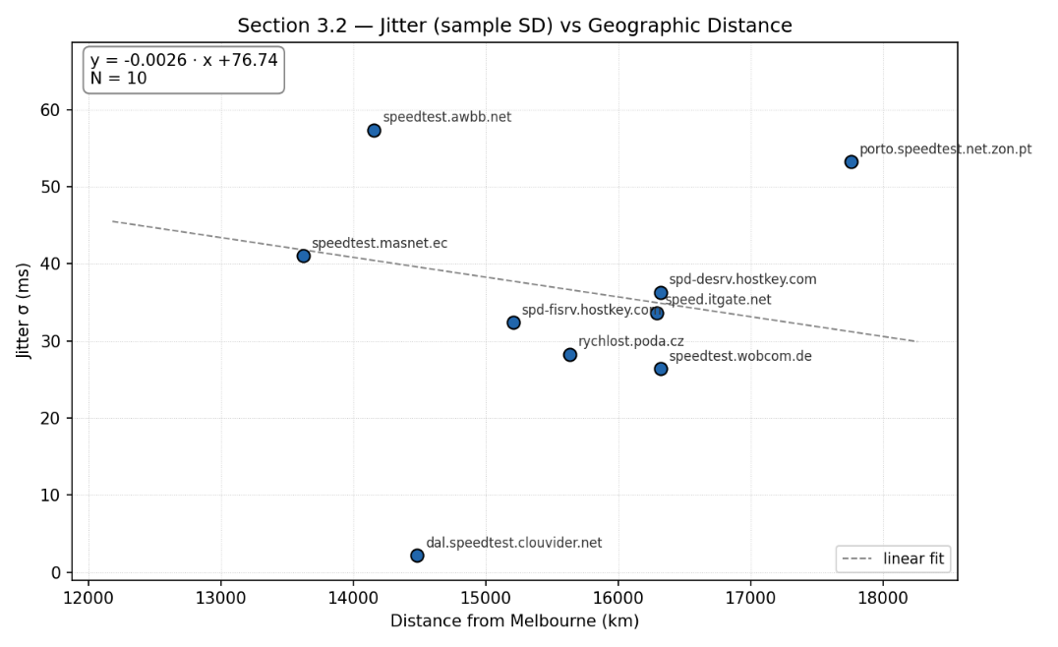
< Fig 3.2.13 Scatter chart (distance VS jitter)>
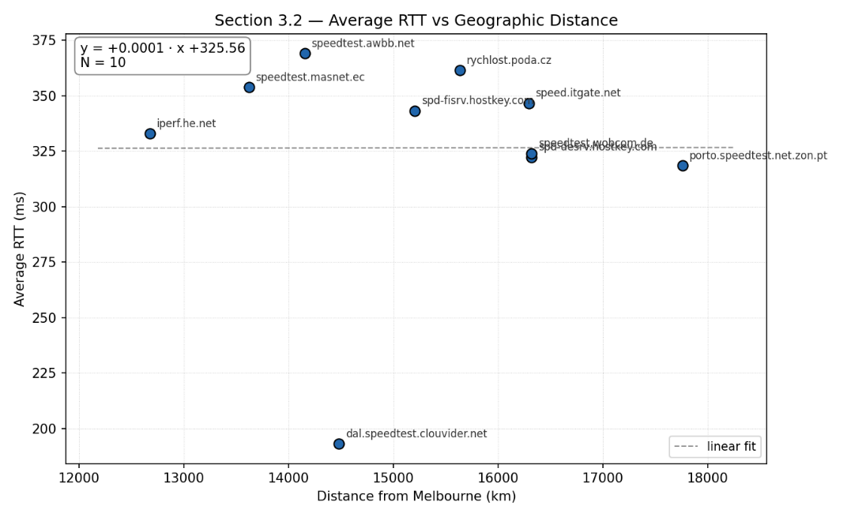
< Fig 3.2.14 Scatter chart (distance VS Avg RTT)>

Ans 3.3
Fig. 3.2.13 clearly shows that the actual physical distance and jitter exhibit a negative correlation; that is, as the distance increases, the jitter parameter continuously decreases. However, observing the coefficients of the fitting function reveals that the correlation is weak. Meanwhile, the chart contains extremely stable factors, such as dal.speedtest.clouvider.net, which also indirectly indicates a weak correlation.
According to Fig 3.2.14, we can clearly see that the coefficient of the fitting function in the chart is approximately 0. At the same time, we can also see directly from the chart that the fitted line is approximately a horizontal line. This reflects that in most cases, the average RTT does not change with geographical location. This suggests that it may be more related to the parameters of the server itself and the signal quality.
All measurements were conducted over a shared Wi-Fi network in a student apartment building, where the wireless access point serves many concurrent users across the entire building. The typical download speed observed on this network is approximately 80 Mbps. During evening peak hours, when residents are streaming video, gaming, and downloading files simultaneously, noticeable increases in latency and network instability were observed.
This shared wireless environment has two significant implications for the results. First, the Wi-Fi access point introduces additional queuing delay underload, which is added to every ping measurement regardless of the destination. This constant local overhead raises the baseline RTT for all hosts and diminishes the relative contribution of geographic propagation delay, helping to explain why RTT shows virtually no correlation with distance (r = 0.002). Second, fluctuations in local network load introduce variability that dominates the jitter measurements. For example, speedtest.masnet.ec recorded a jitter of 42.076ms in Run 1 and 41.764ms in Run 2, but only 5.327ms in Run 3 — an eightfold difference across three runs to the same host over the same path. The only variable that changed between runs was the local network congestion at the time of measurement. Similarly, iperf.he.net recorded an RTT spike of 475.908ms in Run 1 (compared to a typical range of 280–350ms in Runs 2 and 3), which is consistent with a momentary burst of congestion at the local access point.
However, local network conditions alone do not account for all observed variation. dal.speedtest.clouvider.net achieved both the lowest RTT (193.039ms) and the lowest jitter (2.155ms) among all 10 hosts, with highly consistent results across all three runs. This demonstrates that when the end-to-end route is well-optimized — traversing high-capacity backbone networks with minimal congestion — stable performance is achievable even over a shared Wi-Fi connection. In contrast, speedtest.awbb.net, located at a similar distance (14,155 km vs 14,482 km), recorded an RTT of 369.028ms and a jitter of 57.345ms. This nearly twofold difference in RTT for two hosts at comparable distances confirms that routing path quality and intermediate network conditions are far more influential than geographic distance in determining both delay and jitter.

Section 4
Ans 4.1
Firstly, bandwidth-delay product (BDP) is defined as the product of a link's bandwidth and the round-trip delay time [5]. It represents the maximum amount of data that can be in transit on the network at any given moment. A higher BDP indicates that the network path has a larger capacity for in-flight data, which is important for TCP performance — the TCP send window must be at least as large as the BDP to fully utilise the available bandwidth [5]. In summary, the BDP determines the minimum size required for a TCP send window. If the send window is smaller than the BDP, the sender cannot continue sending data while waiting for the ACK, resulting in link utilization falling below 100% and actual throughput being far lower than the available link bandwidth.
Then, we look at Fig 4.1 in section 3 of appendix and make a table to summarize the data in the under Fig 4.1.1 Fig 4.1.2
<Fig 4.1.1 summary for 30times iperf command>
In Fig 4.1.1, there is something need to pay attention in Host 10, since direct access via forward mode was consistently denied, a receiver-side approach was used to read data, i.e., `iperf3 -c iperf.he.net -R`.
<Fig 4.1.2 summary for 30times iperf command>
From Fig 4.1.1 & Fig4.1.2, we could easily find the highest average bandwidth in the ten hosts is 97.97Mbps which belongs to dal.speedtest.clouvider.net. But it’s not the closest host among all the hosts. And the lowest average bandwidth is 13.77Mbps, which belongs to porto.speedtest.net.zon.pt. This is the furthest host among all.
Therefore, we use Mean Bandwidth (Mbps) and distance to fit a linear trendline. The last, Host 4 and Host 6 each had one abnormally low value (3.98 and 1.12 Mbps respectively), which may have been caused by momentary server congestion.
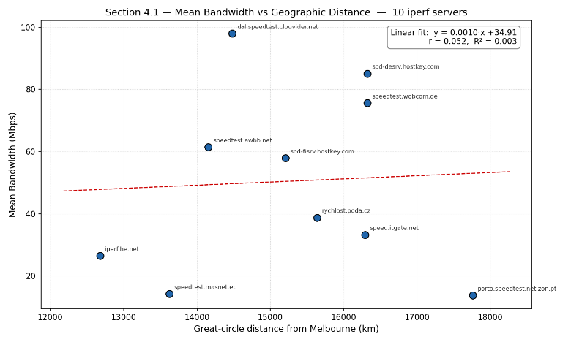
<Fig 4.1.3 Scatter chart and fitted linear for mean Bandwidth VS Distance>
According to Fig 4.1.3, the regression equation in the chart has coefficients approximately greater than 0, and an R² of about 0.0027, indicating a weak correlation and a positive correlation trend, meaning that the bandwidth increases slightly with distance.

Ans 4.2
Looking at Fig 4.2.1 and Fig 4.2.2 in section 4 of the appendix
<Fig 4.2.3 Table for the Furthest and closest iperf servers in the whole day >
Porto (furthest, 17 761 km) exhibited remarkably stable throughput across all four time slots, ranging only from 13.4 to 13.8 Mbps (SD = 0.19 Mbps). The traceroute path remained consistent at 15 hops, and RTT held steady at 268–270 ms for the first three periods. This stability strongly suggests that the bottleneck lies not in path congestion but at the terminal link — most likely port-level throttling on the Porto server or its upstream ISP, imposing a hard cap near 13.8 Mbps. The Night slot further supports this interpretation: RTT rose by 35 ms to 304 ms, yet bandwidth barely moved (13.6 Mbps), confirming that additional latency alone does not reduce throughput when a fixed-rate bottleneck is already binding.

Ecuador (closest, 13 621 km) showed far greater variability, with throughput spanning 20.6–24.4 Mbps (SD = 1.75 Mbps) — roughly nine times Porto's SD. Two observations stand out. First, the Evening slot (AEST 18:09) recorded the highest bandwidth at 24.4 Mbps. This is counterintuitive until the time-zone offset is considered: AEST 18:09 corresponds to approximately 03:00 local time in Ecuador, a deep off-peak window where destination-side congestion is minimal. Second, the Night slot (AEST 23:08) saw bandwidth drop to 20.8 Mbps while RTT spiked from ~326 ms to 413 ms. The traceroute reveals the source: hop 24 (voip.masnet.ec) exhibited wild RTT fluctuation (524/327/388 ms), whereas the same hop in the Morning trace was perfectly stable (327/327/327 ms). The hostname prefix "voip" indicates this is a VoIP gateway within the Ecuadorian network; by AEST 23:08 it is roughly 08:00 local time — the start of the business day — and the resulting traffic surge introduces congestion at this specific node, degrading both latency and throughput.
<Fig 4.2.4 Summary for the Furthest and closest Iperf server in the whole day >
From Fig 4.2.4, the data clearly shows that although the bandwidth of the furthest server—Portugal—is only half that of the nearest server—Ecuador—it remains relatively stable throughout all four time periods of the day, without significant fluctuations. And Porto's SD (0.19 Mbps) is only about one-tenth of Ecuador 's (1.75 Mbps). Porto is limited by a fixed terminal bandwidth cap, and time-of-day changes have almost no impact on it; while Ecuador does not have such a hard rate limit, and its throughput is greatly affected by intermediate nodes in the path (especially VoIP gateways) and local usage patterns at the destination.

We could plot one chart to show the result more clearly.
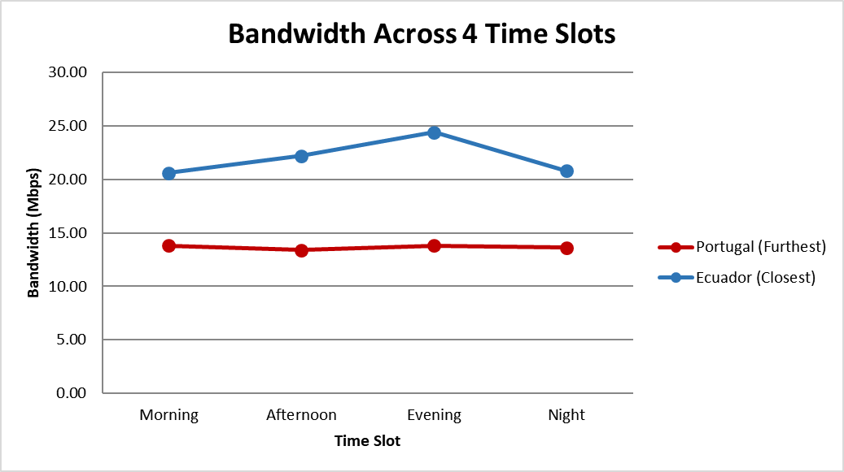
<Fig 4.2.5 Chart for the Furthest and closest iperf servers in the whole day>

Ans 4.3
We used the data from section 3.2 and 4.1. Then we multiplied them with each other to get BDP.
BDP = mean RTT * mean Bandwidth
<Fig 4.3.1 Summary for mean RTT and mean Bandwidth>
Then we plot two bar charts with a linear scale and a logarithmic scale.
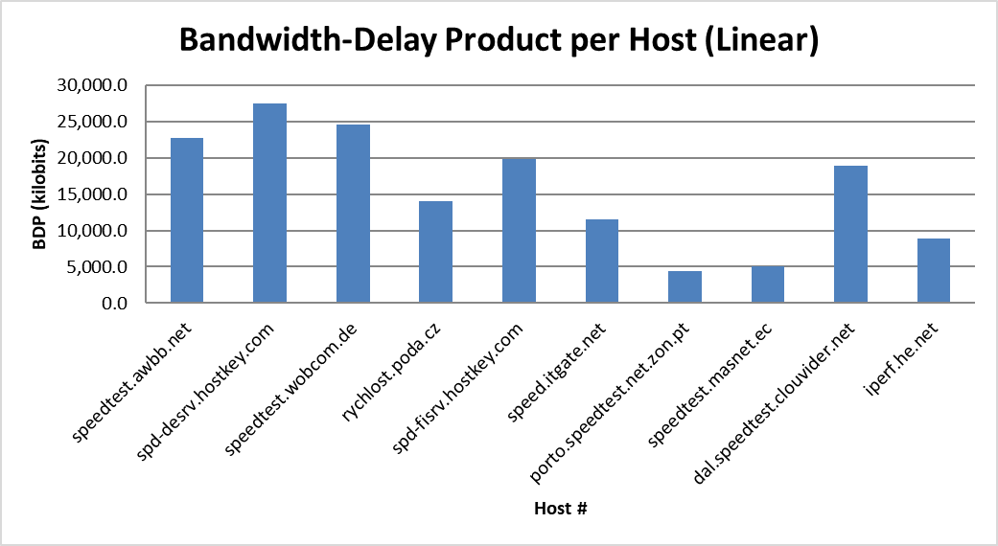
< Fig 4.3.2 Bar chart with a linear scale for 10 iperf servers>
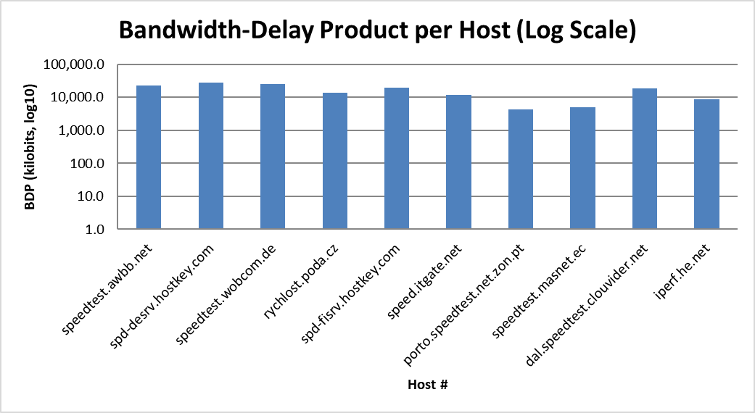
< Fig 4.3.3 Bar chart with a logarithmic scale for 10 iperf servers>
Two scales are used here, mainly because the BDP of the minimum value Host7 and the maximum value Host2 differ by nearly 7 times, so a logarithmic scale can certainly be used.
The bandwidth-delay product (BDP) for each host was calculated using the formula BDP = Mean Bandwidth × Mean RTT, where the mean bandwidth values were obtained from the iperf measurements in Section 4.1 and the mean RTT values from the ping measurements in Section 3.2.
The highest BDP belongs to spd-desrv.hostkey.com (3,347 KB), despite it not having the highest bandwidth. This is because BDP is the product of both bandwidth and delay: spd-desrv achieves a high bandwidth of 85.1 Mbps combined with a relatively high RTT of 322.2ms, resulting in a large "pipe" that can hold a significant amount of in-flight data. In contrast, dal.speedtest.clouvider.net has the highest measured bandwidth (98.0 Mbps) but the lowest RTT (193.0ms), so its BDP ranks only fifth at 2,309 KB. This illustrates an important characteristic of BDP: a low BDP does not necessarily indicate poor network performance. dal.clouvider delivers the best throughput and the most stable connection among all 10 hosts, yet its short round-trip time means fewer bytes need to be in flight at any given moment to keep the pipeline full. From a TCP performance perspective, a lower BDP is actually easier to manage, as it requires a smaller TCP send window to achieve full link utilisation [5].
The two lowest-ranked hosts, porto.speedtest.net.zon.pt (535 KB) and speedtest.masnet.ec (615 KB), both have BDP values well below the average of 1,918 KB. Their low rankings are driven primarily by their limited bandwidth (13.8 and 14.2 Mbps respectively), rather than by their RTT values. As discussed in Section 4.2, Porto’s bandwidth is constrained by what appears to be ISP-level or server-side rate limiting at approximately 13.8 Mbps, while Ecuador server’s capacity is similarly limited. No matter how high the RTT, the BDP cannot grow when the bandwidth is capped at such a low level.
The measurements were conducted over a shared Wi-Fi network with an observed download speed of approximately 80 Mbps. This means that for hosts where the measured iperf throughput approaches or exceeds 80 Mbps — such as dal.speedtest.clouvider.net (98.0 Mbps) and spd-desrv.hostkey.com (85.1 Mbps) — the local wireless link may itself have become the bottleneck. In these cases, the true end-to-end BDP of the network path could be higher than what was measured, as the local access point limits the achievable throughput. For hosts with lower bandwidth measurements, such as Porto and Ecuador, the bottleneck lies at the remote end rather than the local network, and the measured BDP is likely representative of the actual path capacity.

Ans 4.4
Challenge 1: iperf.he.net refused default (sender) mode connections.
When running the standard iperf3 command (iperf3 -c iperf.he.net) against Host 10 (iperf.he.net), the server refused the connection in its default mode, where the client sends data to the server. This is not a network connectivity issue but rather a server-side policy restriction — the iperf3 server at iperf.he.net is configured to only accept reverse-mode connections. To resolve this, the “-R” flag was used (iperf3 -c iperf.he.net -R)[6], which reverses the data flow direction so that the server sends data to the client instead. This resulted in successful bandwidth measurements across all three runs. It is worth noting that the -R flag is an iperf3-specific feature and is not available in iperf2, which is why iperf3 was used for this host while iperf2 was used for the remaining nine hosts.

Challenge 2: Significant jitter spike on the Ecuador server's path during the nighttime slot.
During the Section 4.2 night measurement (AEST 23:08), the traceroute to the Ecuador server revealed a severe jitter spike at hop 24 (voip.masnet.ec, 170.83.216.5), with RTT values of 524.668ms, 327.077ms, and 388.391ms across the three probes. In comparison, the morning traceroute for the same hop recorded a stable 327/327/328ms. This hop is labelled "VoIP" in its hostname, suggesting it functions as a VoIP gateway within the Ecuador ISP's network. The instability at this node during the nighttime slot (corresponding to approximately 08:00 local time in Ecuador, the start of business hours) is consistent with increased traffic load from voice and data services. This jitter spike also coincided with the final-hop RTT increasing from ~326ms to 413ms, and the iperf bandwidth dropping to 20.8 Mbps (the second-lowest value across the four time slots). However, the TCP connection did not collapse entirely, indicating that TCP's congestion control and windowing mechanisms were able to absorb the jitter to some extent, maintaining a usable level of throughput despite the unstable intermediate node.

References

[1] db-ip.com, "IP Geolocation," db-ip.com. [Online]. Available: https://db-ip.com/. [Accessed: Apr. 2026].
[2] R. W. Sinnott, "Virtues of the Haversine," Sky and Telescope, vol. 68, no. 2, p. 159, 1984.
[3] J. F. Kurose and K. W. Ross, Computer Networking: A Top-Down Approach, 8th ed. Harlow, U.K.: Pearson, 2021.
[4] J. Postel, "Internet Control Message Protocol," RFC 792, Internet Engineering Task Force, Sep. 1981. [Online]. Available: https://www.rfc-editor.org/rfc/rfc792
[5] V. Jacobson, R. Braden, and D. Borman, "TCP Extensions for High Performance," RFC 1323, Internet Engineering Task Force, May 1992. [Online]. Available: https://www.rfc-editor.org/rfc/rfc1323
[6] ESnet, "iperf3: A TCP, UDP, and SCTP network bandwidth measurement tool," Energy Sciences Network, 2024. [Online]. Available: https://software.es.net/iperf/

Appendix
Section 2
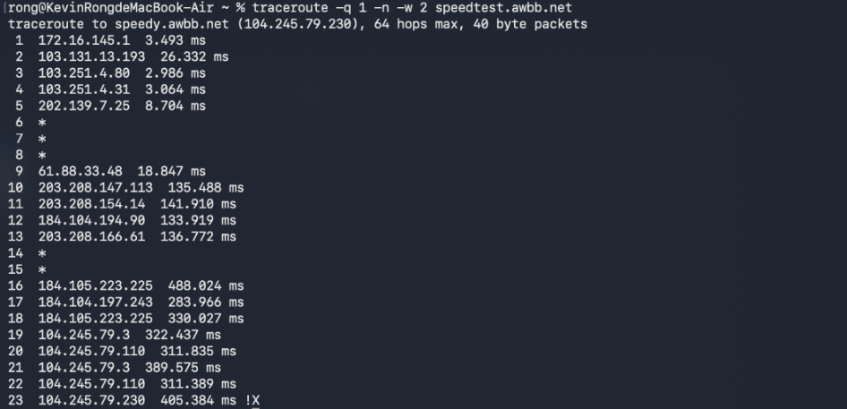
<Fig 2.1.2 traceroute command line for only one packet from my apartment to speedtest.awbb.net>
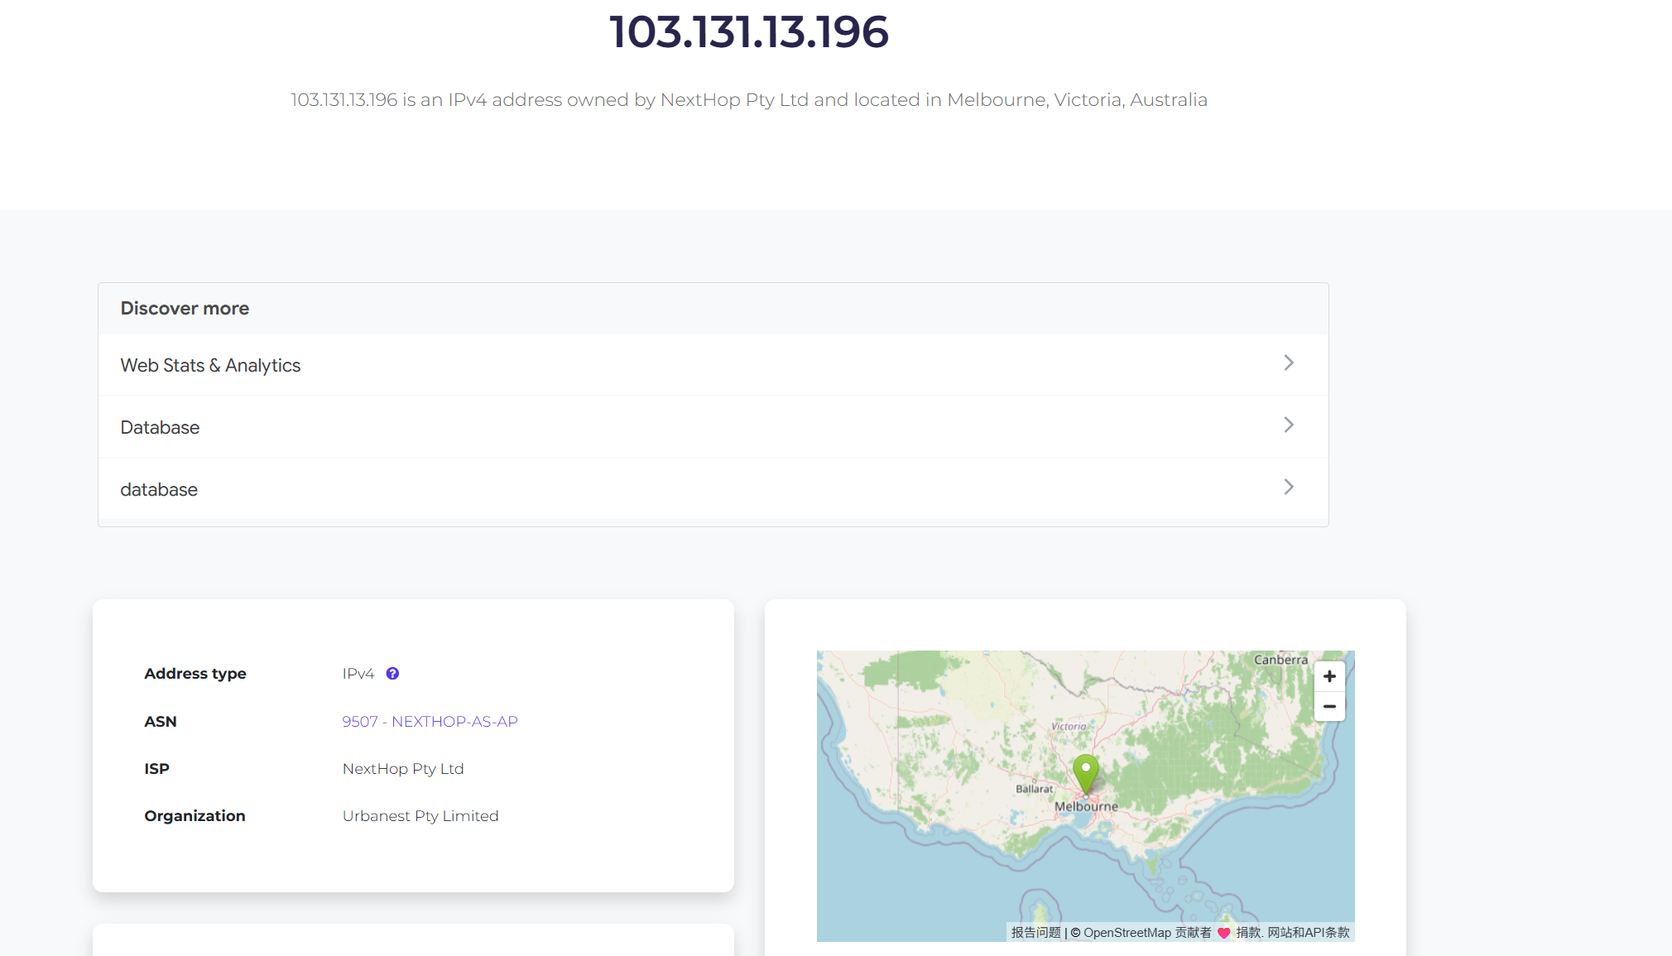
< Fig 2.1.3 IP of 2nd hop >
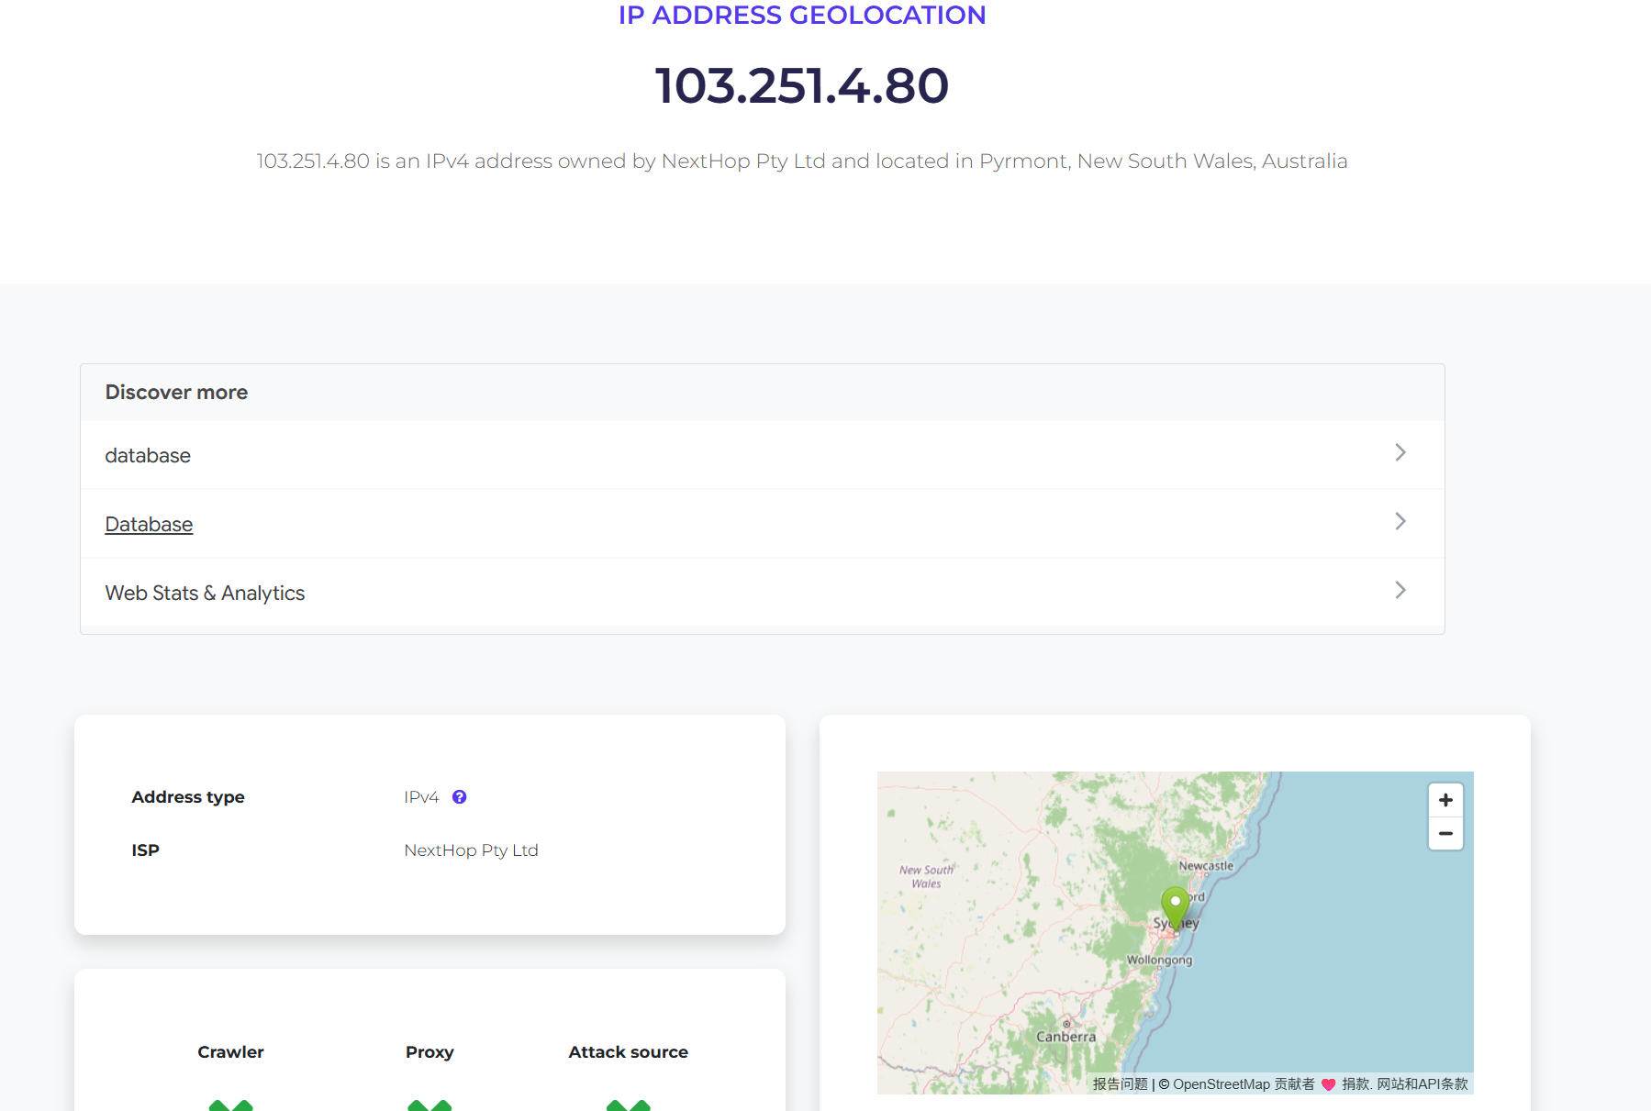
< Fig 2.1.4 IP of 3rd hop >
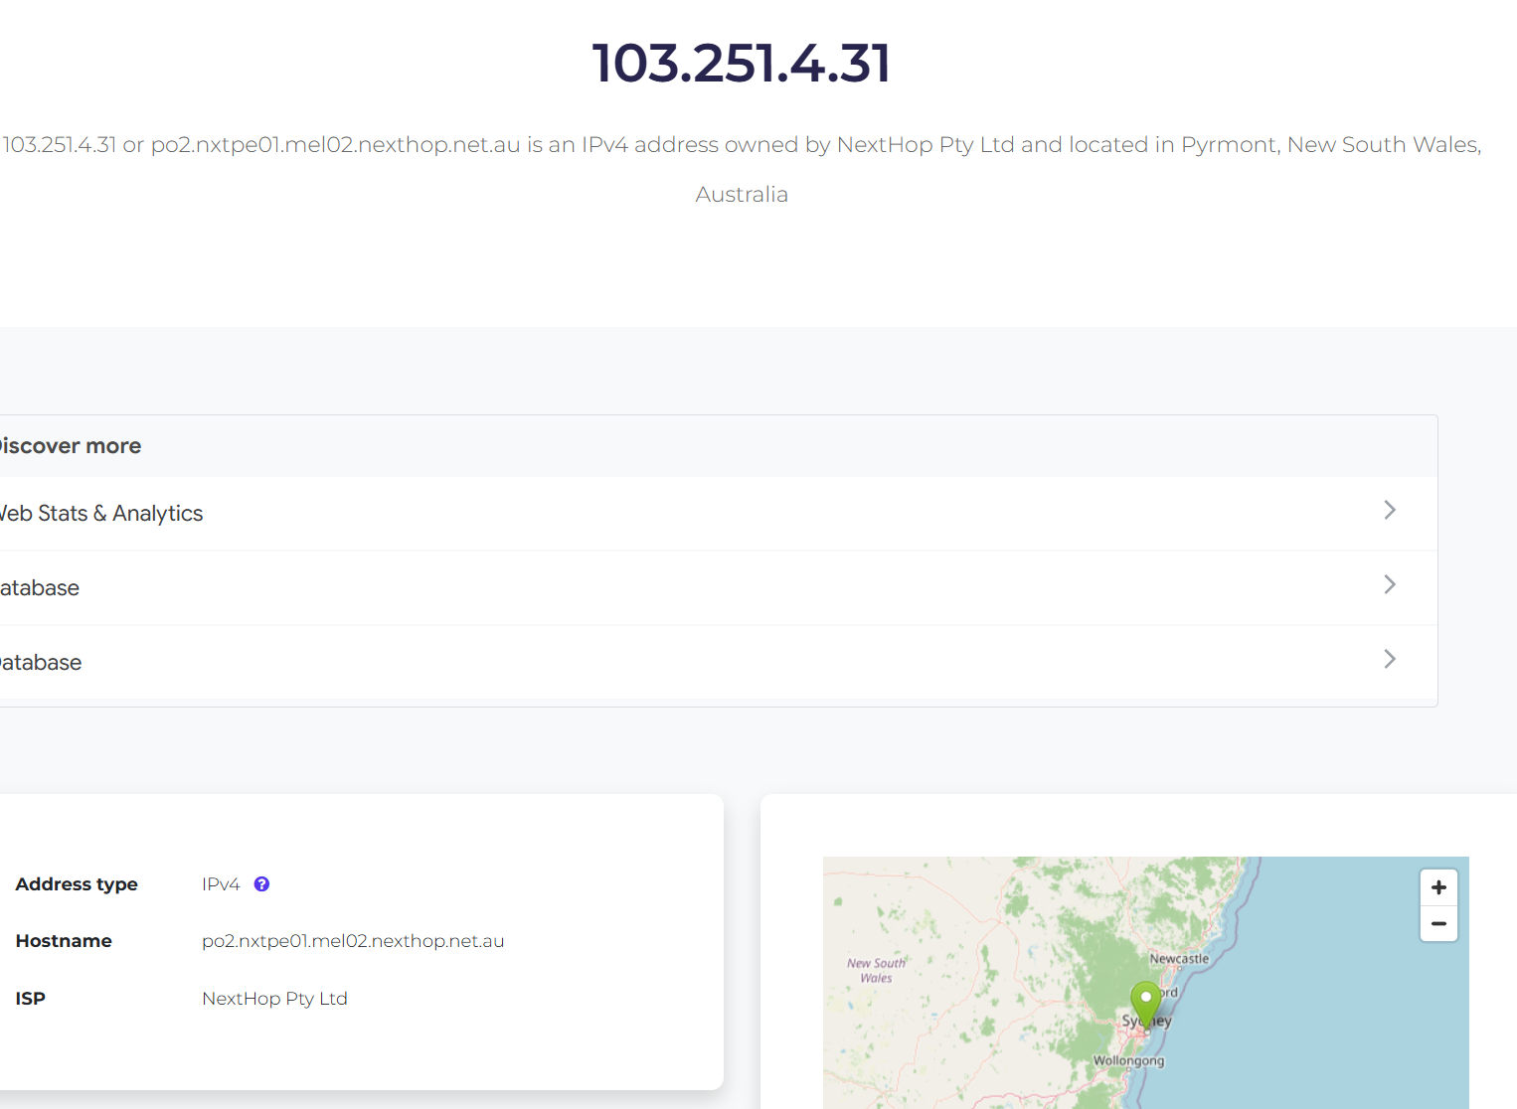
< Fig 2.1.5 IP of 4th hop >
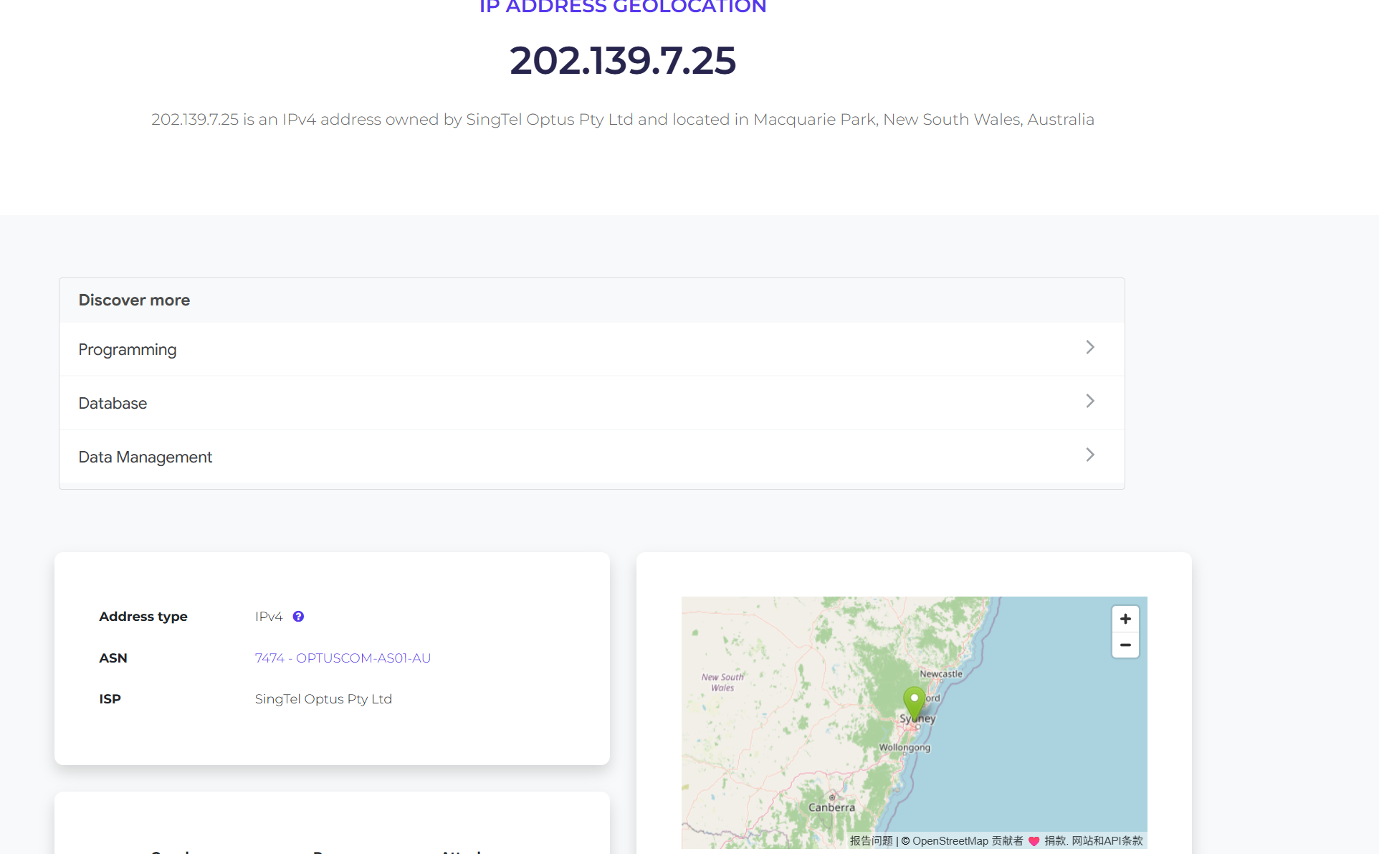
< Fig 2.1.6 IP of 5th hop >
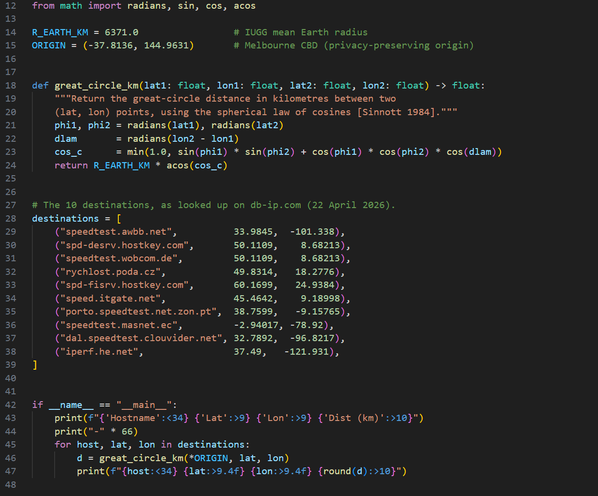
<Fig 2.2.3 Python for distance>
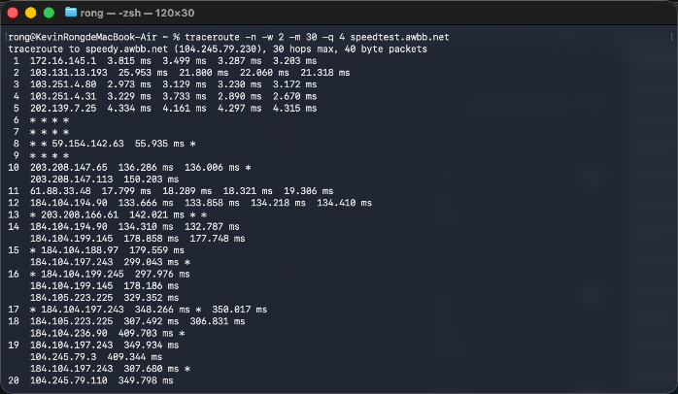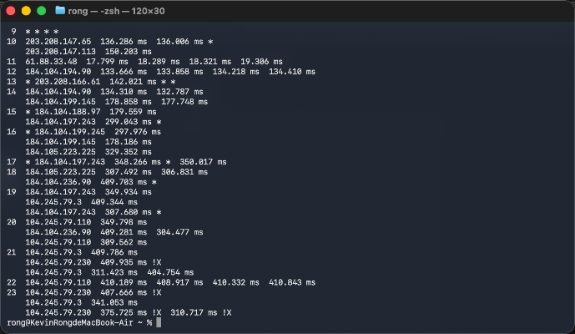
<Fig 2.2.4(a) speedtest.awbb.net> < Fig 2.2.4(b) speedtest.awbb.net>
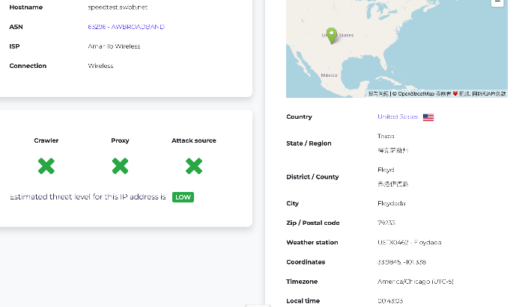
<Fig 2.2.4(c) speedtest.awbb.net>
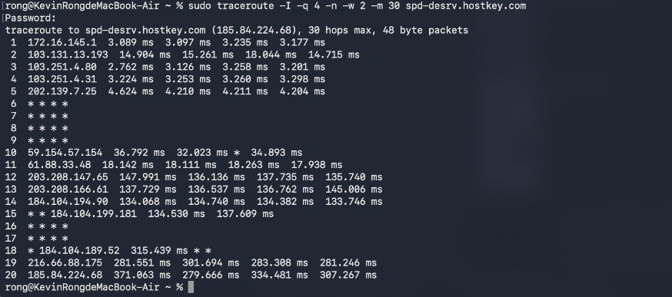
<Fig2.2.5(a) spd-desrv.hostkey.com>
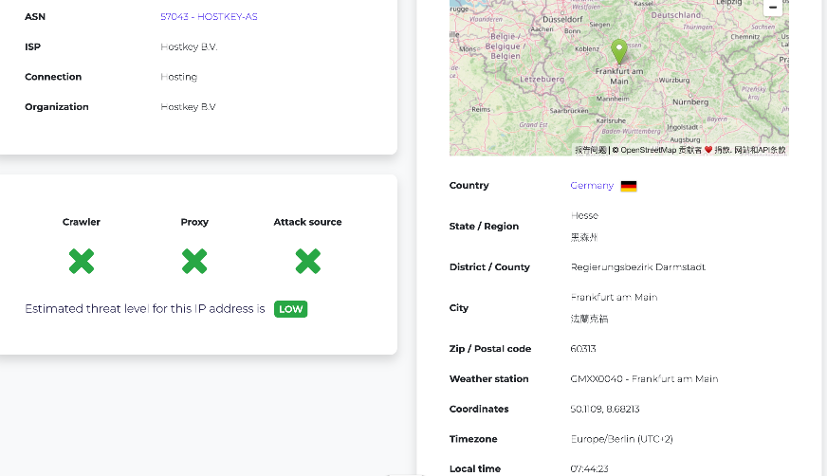
<Fig2.2.5(b) spd-desrv.hostkey.com>
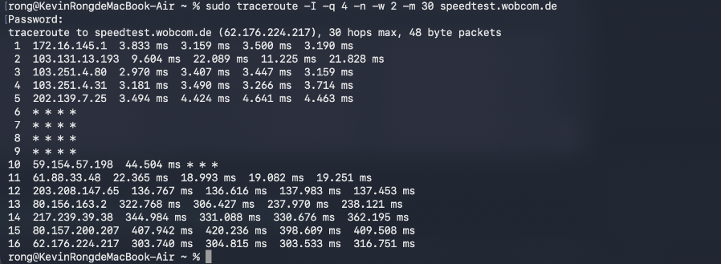
<Fig 2.2.6(a) speedtest.wobcom.de>
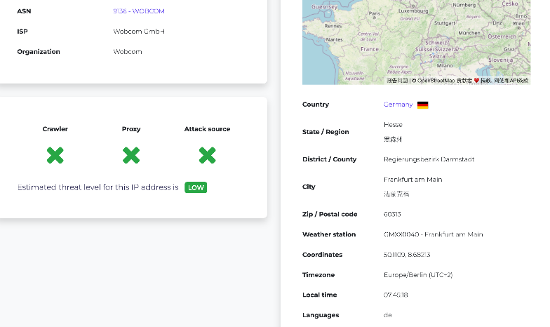
<Fig 2.2.6(b) speedtest.wobcom.de>
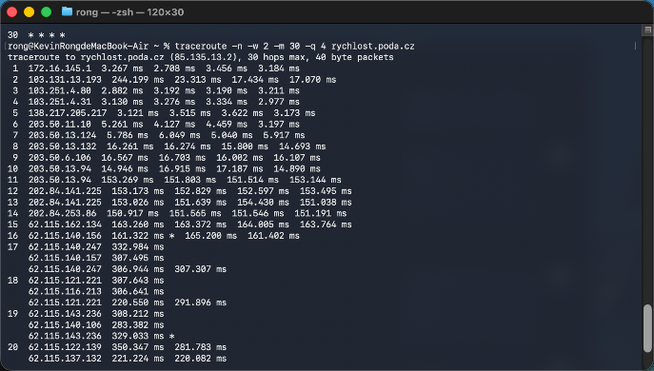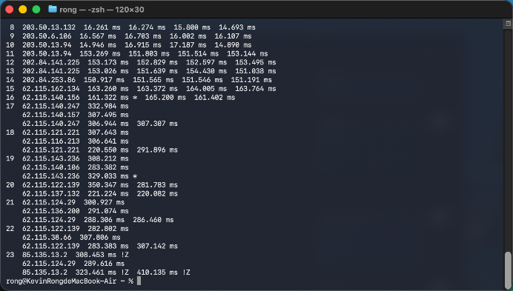
< Fig 2.2.7(a) rychlost.poda.cz > < Fig 2.2.7(b) rychlost.poda.cz >
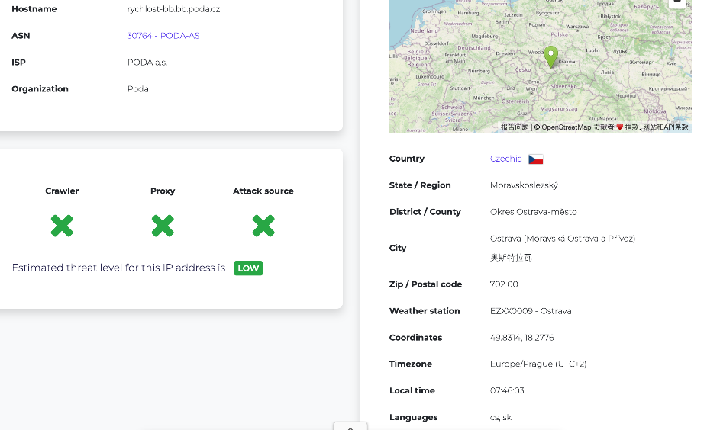
<Fig 2.2.7(c) rychlost.poda.cz >
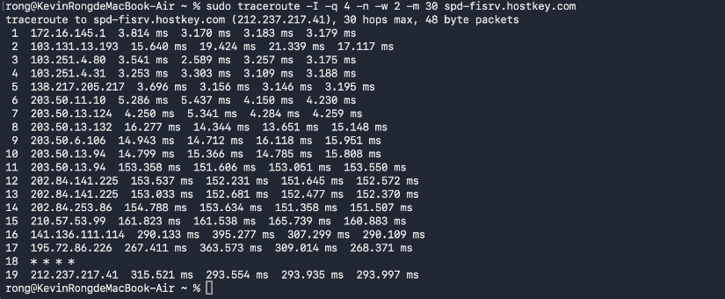
< Fig 2.2.8(a) spd-fisrv.hostkey.com >
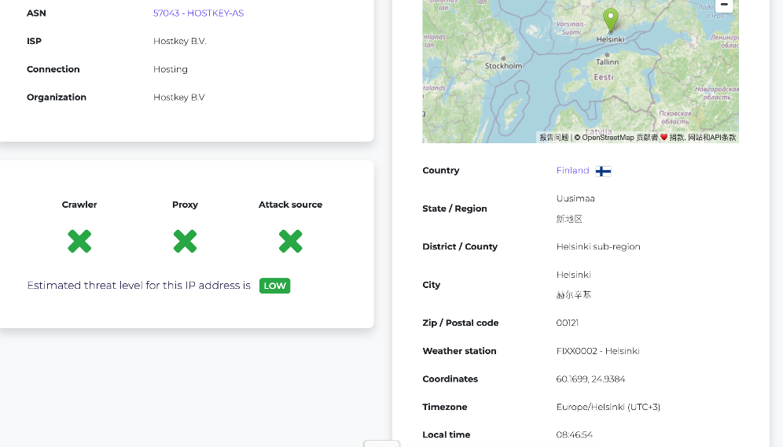
< Fig 2.2.8(b) spd-fisrv.hostkey.com >
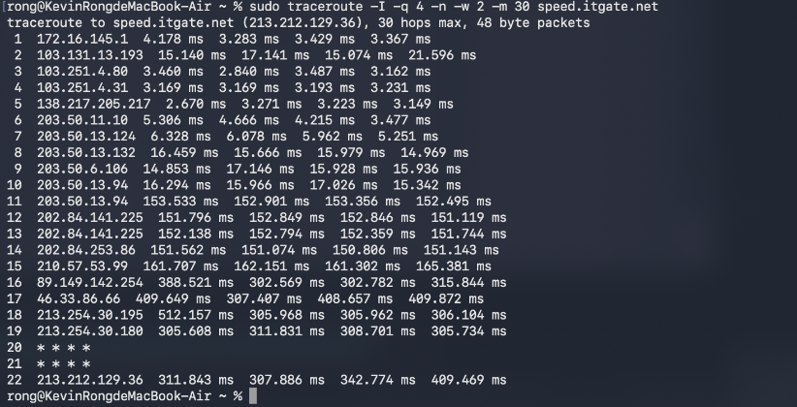
< Fig 2.2.9(a) speed.itgate.net >
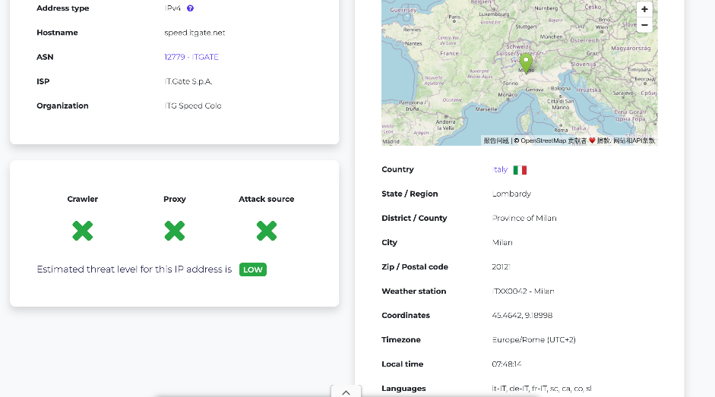
< Fig 2.2.9(b) speed.itgate.net >
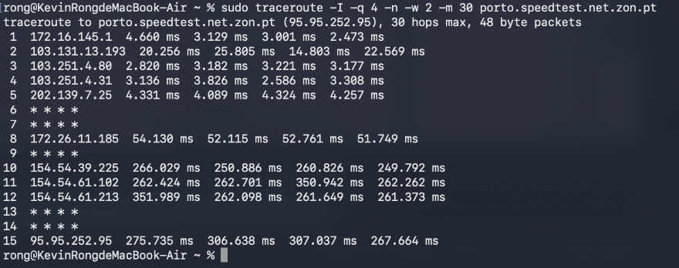
< Fig 2.2.10(a) porto.speedtest.net.zon.pt >
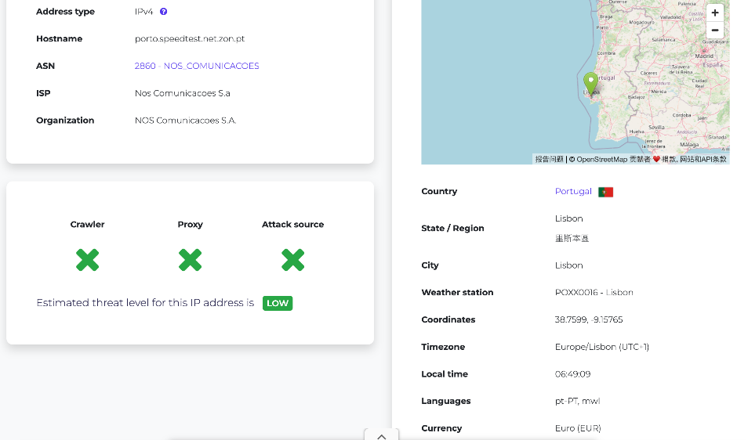
< Fig 2.2.10(b) porto.speedtest.net.zon.pt >
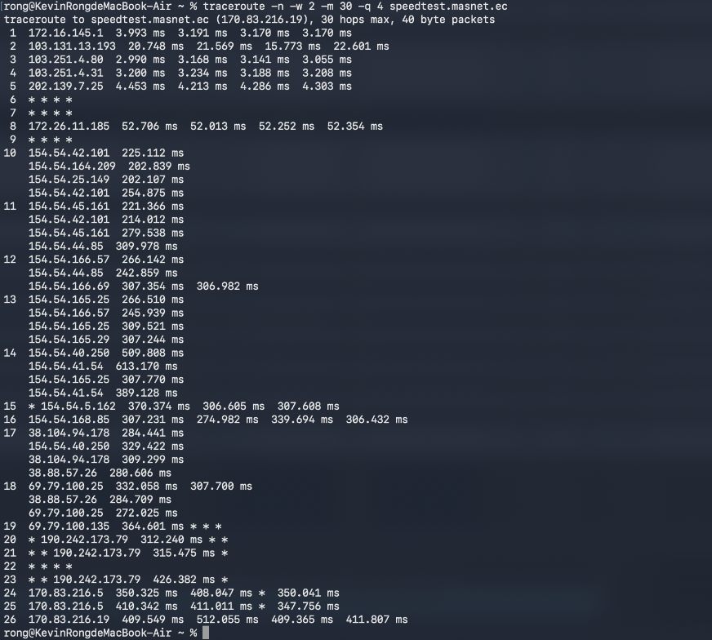
< Fig 2.2.11(a) speedtest.masnet.ec >
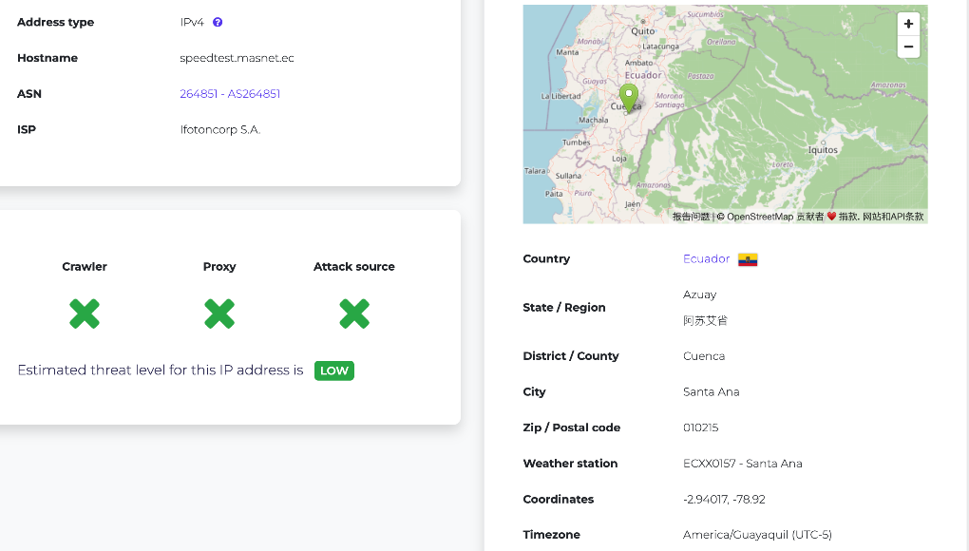
< Fig 2.2.11(b) speedtest.masnet.ec >
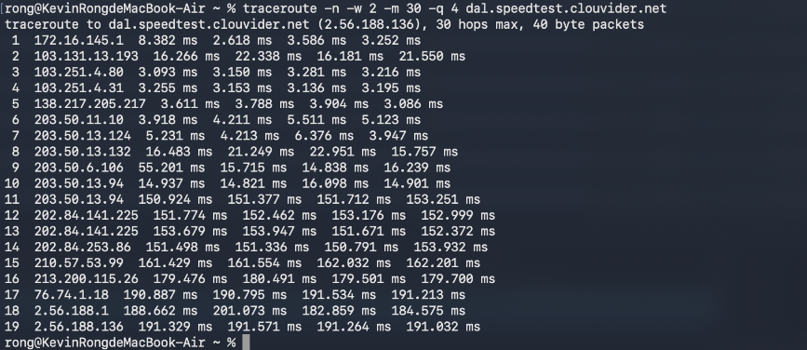
< Fig 2.2.12(a) dal.speedtest.clouvider.net >
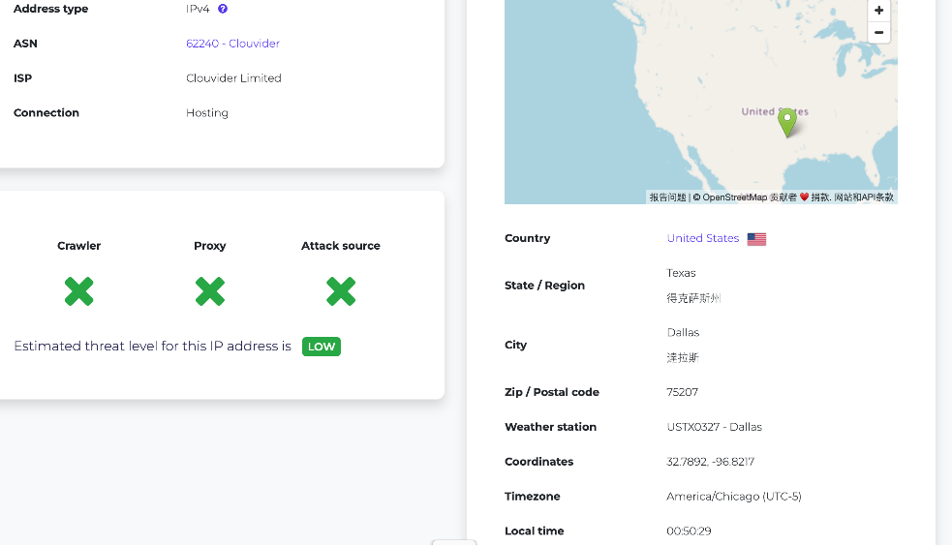
< Fig 2.2.12(b) dal.speedtest.clouvider.net >
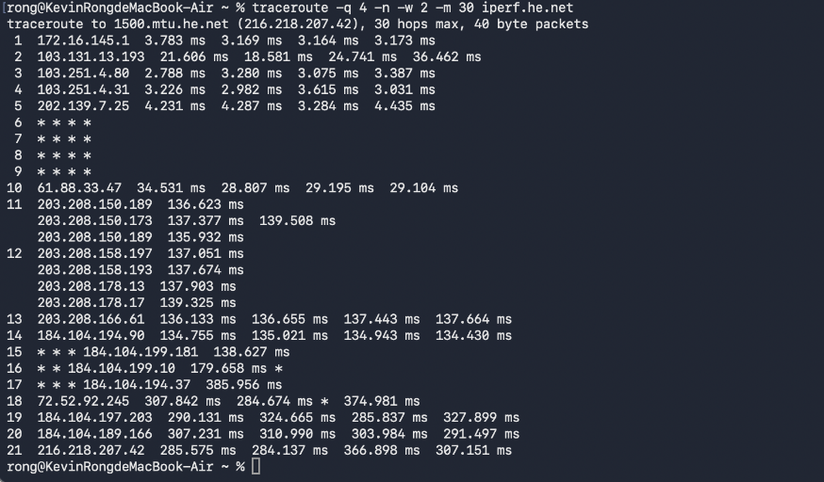
< Fig 2.2.13(a) iperf.he.net >
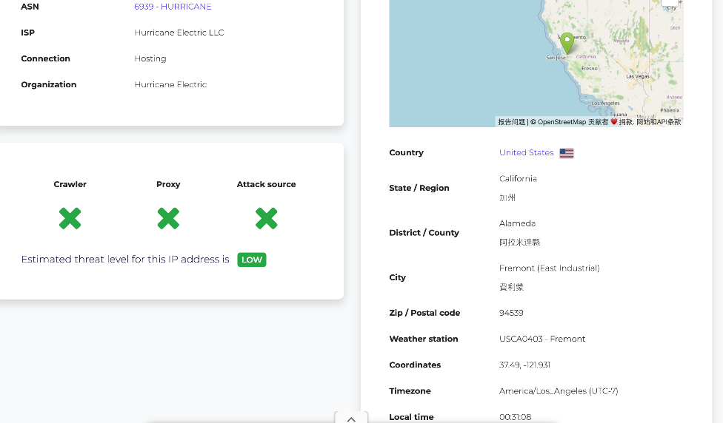
< Fig 2.2.13(b) iperf.he.net >

Section 3
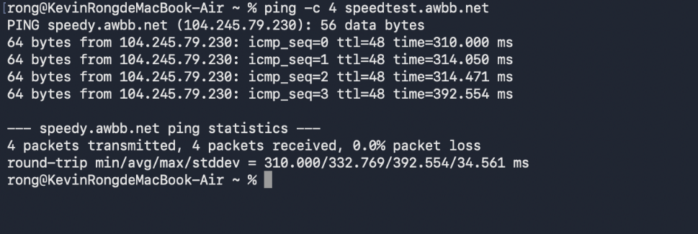
<Fig 3.1.2 ping for speedtest.awbb.net>
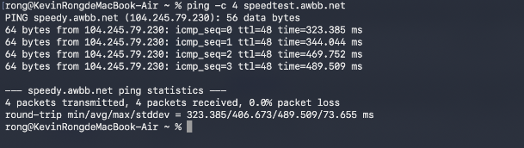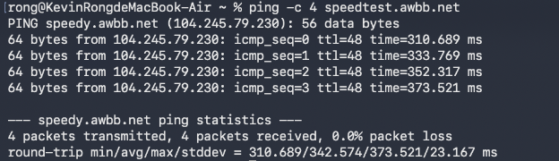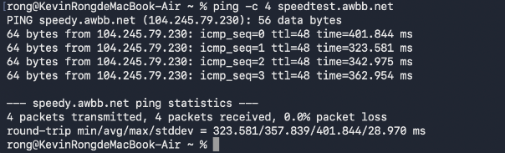
<Fig 3.2.1 3 times ping for speedtest.awbb.net>
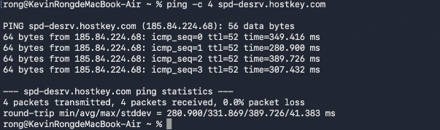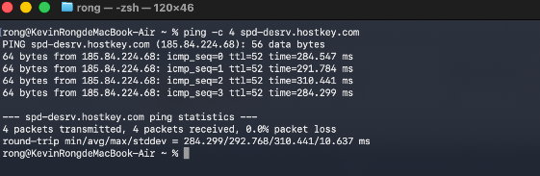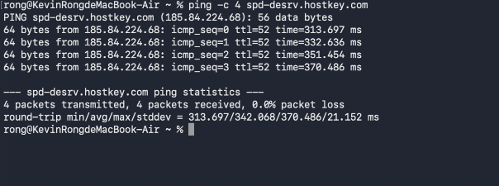
<Fig 3.2.2 3 times ping for spd-desrv.hostkey.com>
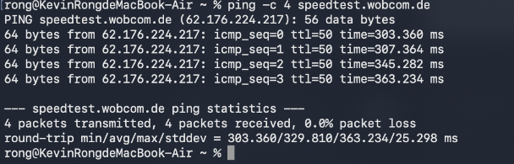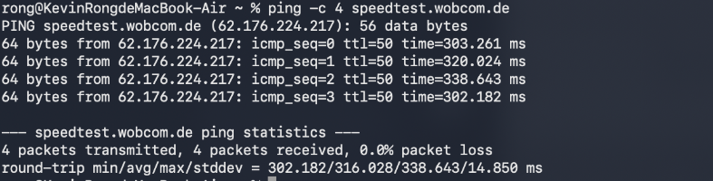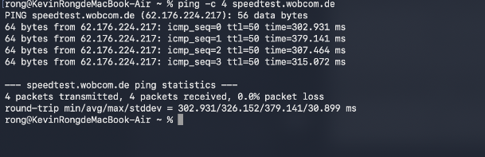
<Fig 3.2.3 3 times ping for speedtest.wobcom.de>

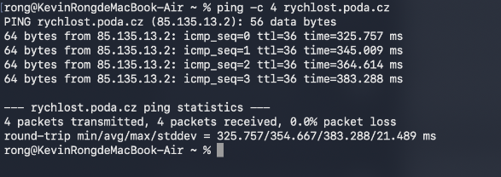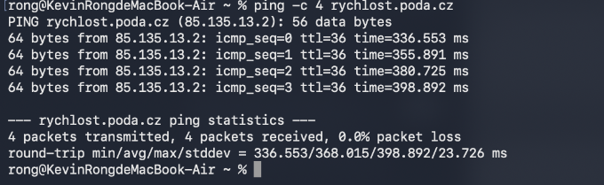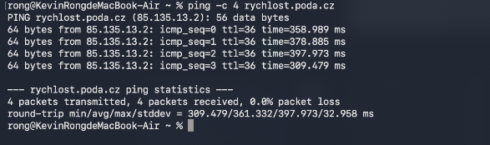
<Fig 3.2.4 3 times ping for rychlost.poda.cz>
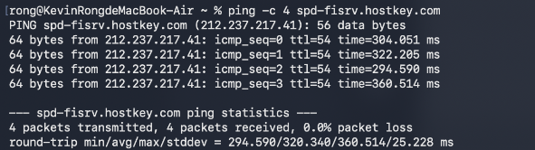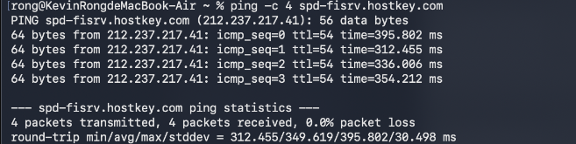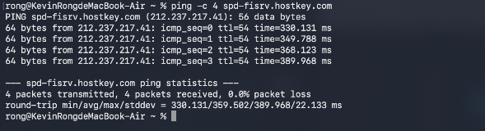
<Fig 3.2.5 3 times ping for spd-fisrv.hostkey.com>
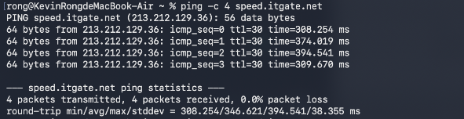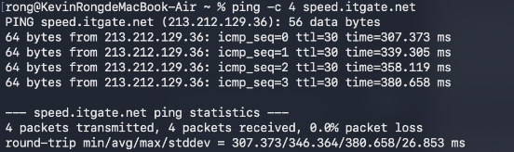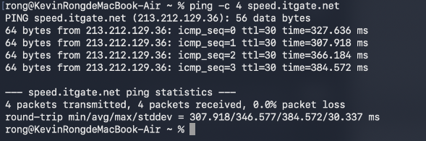
<Fig 3.2.6 3 times ping for speed.itgate.net>
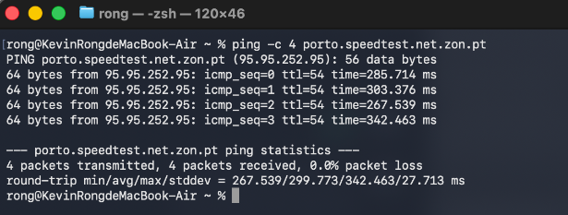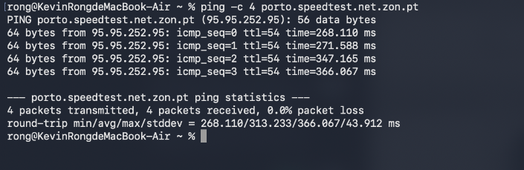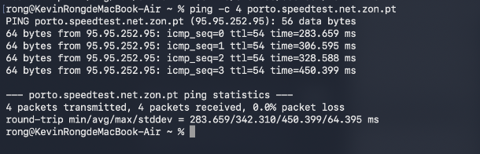
<Fig 3.2.7 3 times ping for porto.speedtest.net.zon.pt>

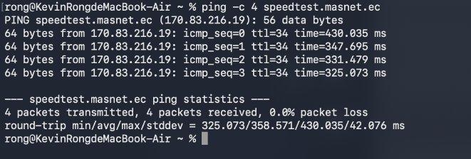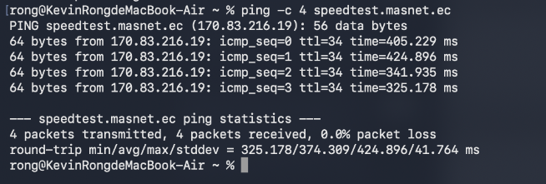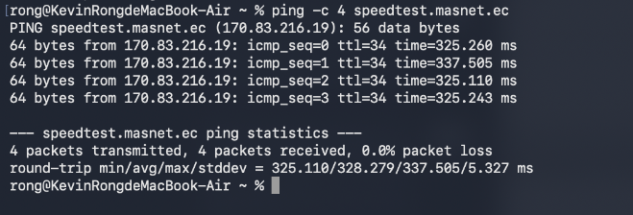
<Fig 3.2.8 3 times ping for speedtest.masnet.ec>
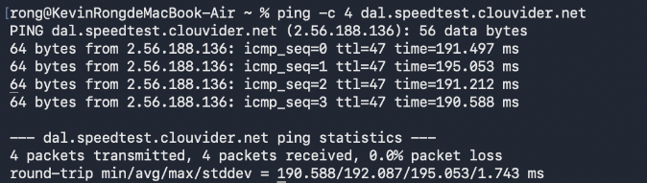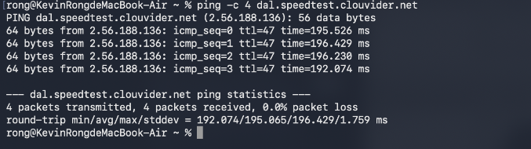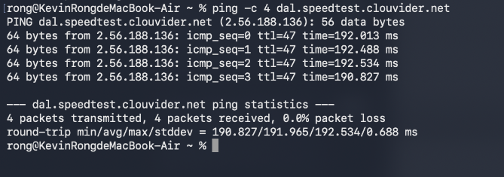
<Fig 3.2.9 3 times ping for dal.speedtest.clouvider.net>
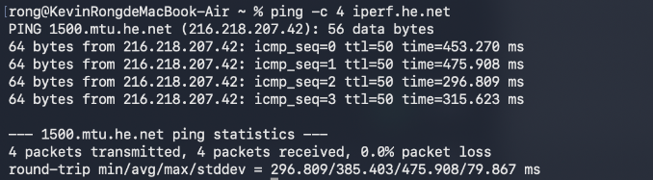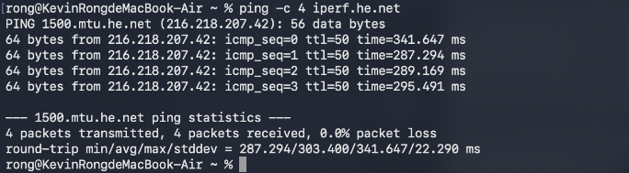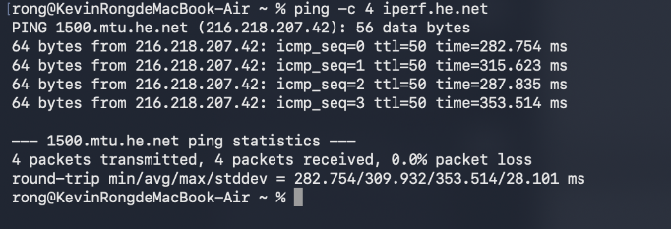
<Fig 3.2.10 3 times ping for iperf.he.net>

Section 4
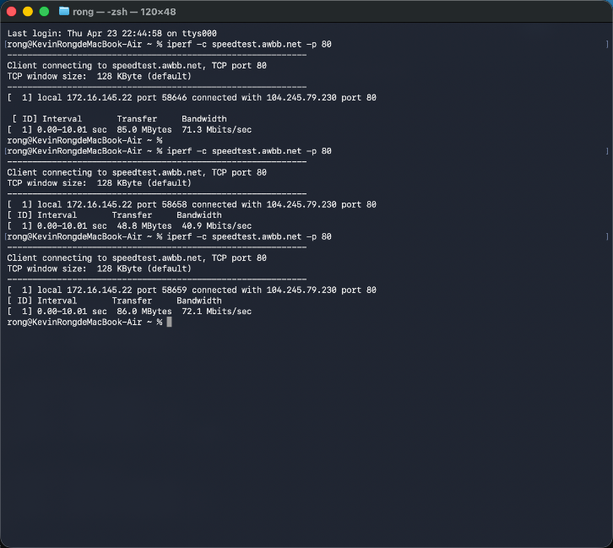
<4.1(a) speedtest.awbb.net>
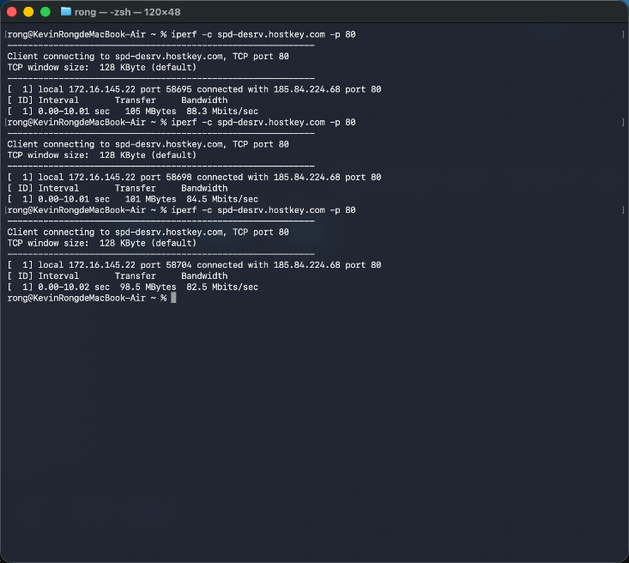
<4.1(b) spd-desrv.hostkey.com>
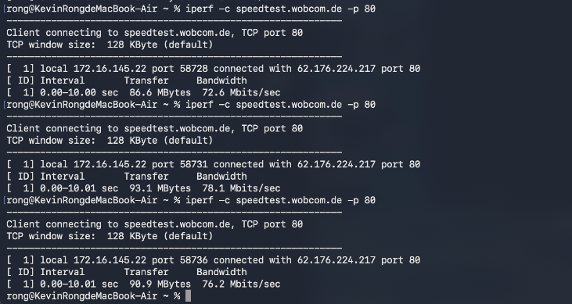
<4.1(c) speedtest.wobcom.de>
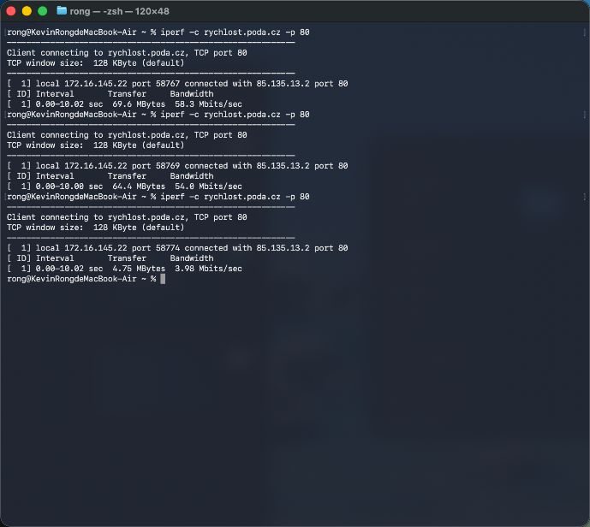
<4.1(d) rychlost.poda.cz>
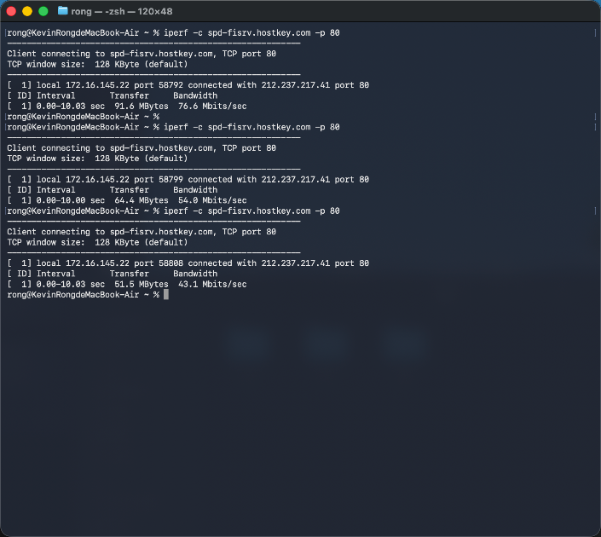
<4.1(e) spd-fisrv.hostkey.com>
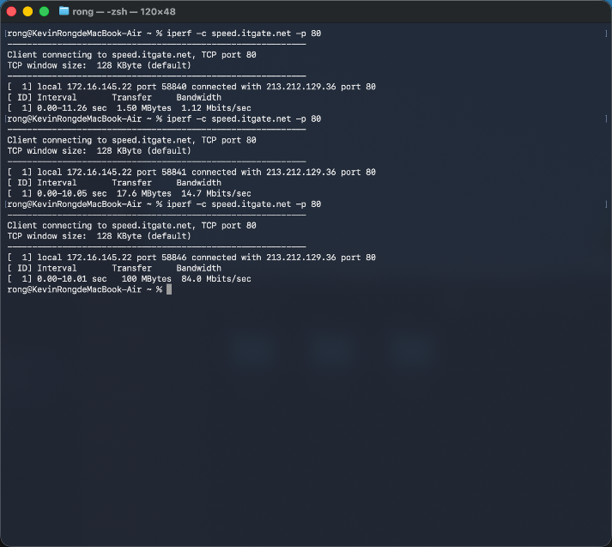
<4.1(f) speed.itgate.net>

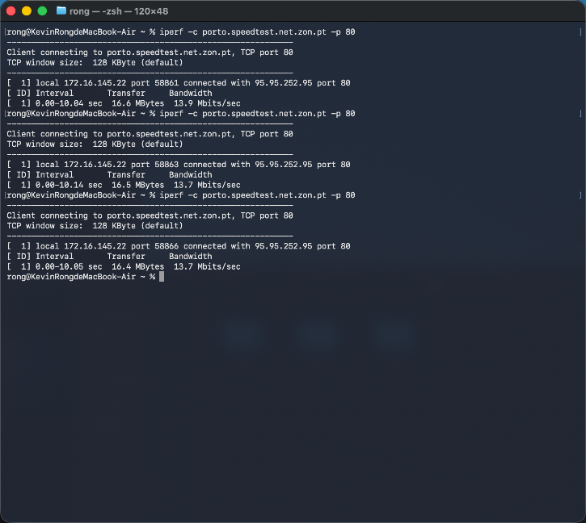
<4.1(g) porto.speedtest.net.zon.pt>
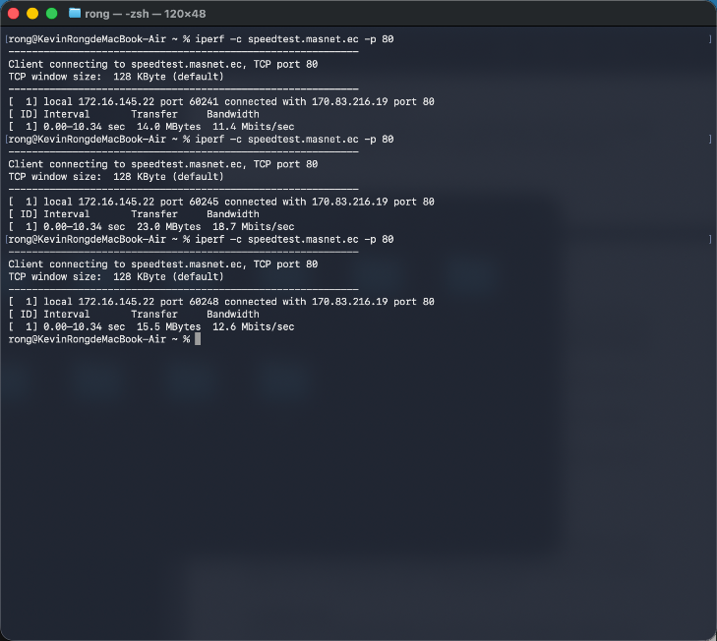
<4.1(h) speedtest.masnet.ec>
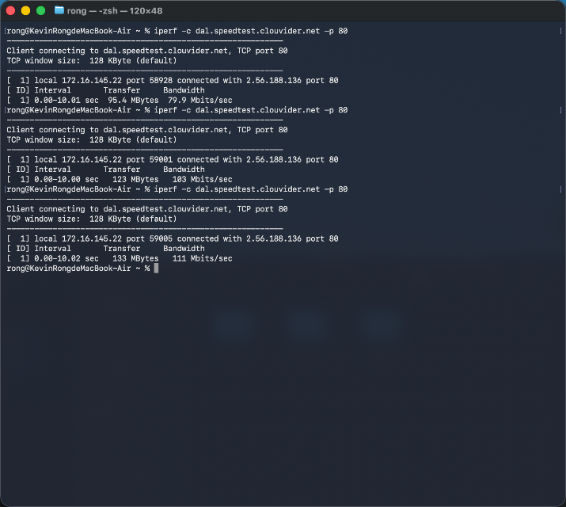
<4.1(i) dal.speedtest.clouvider.net>
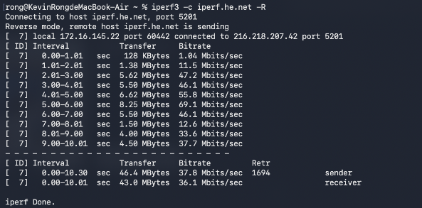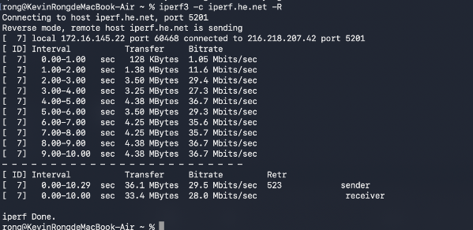
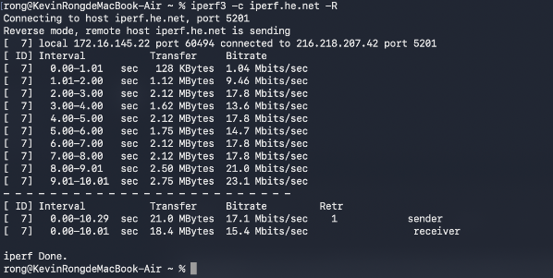
<4.1(j) iperf.he.net>

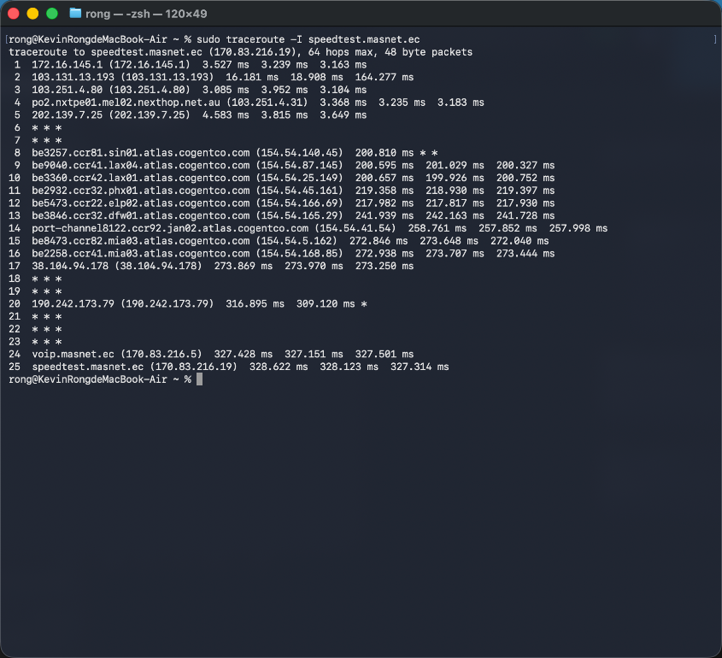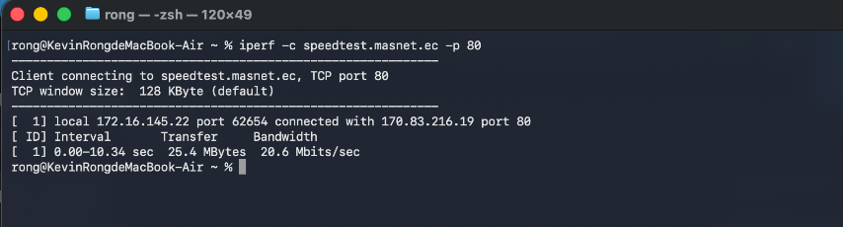
<4.2.1(a) Ecuador (Closest) – morning >
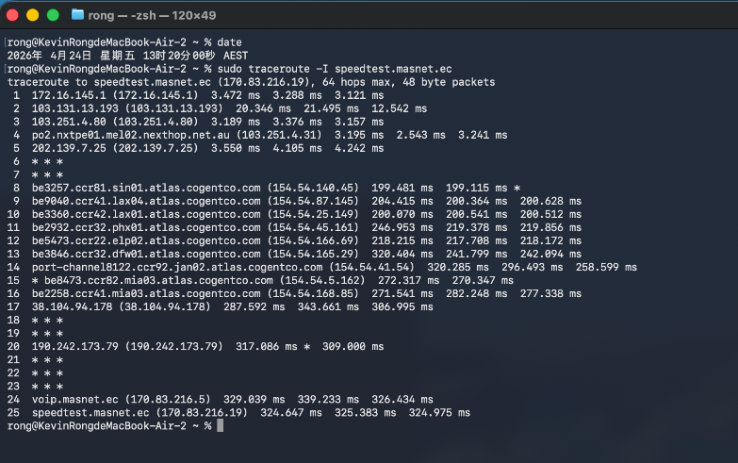
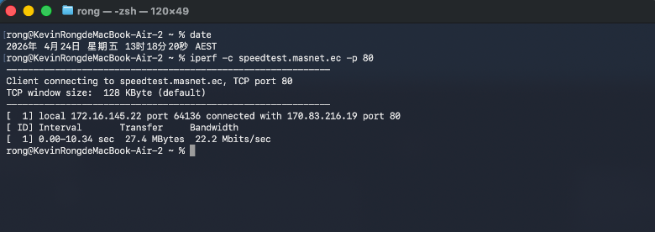

<4.2.1(b) Ecuador (Closest) – afternoon >
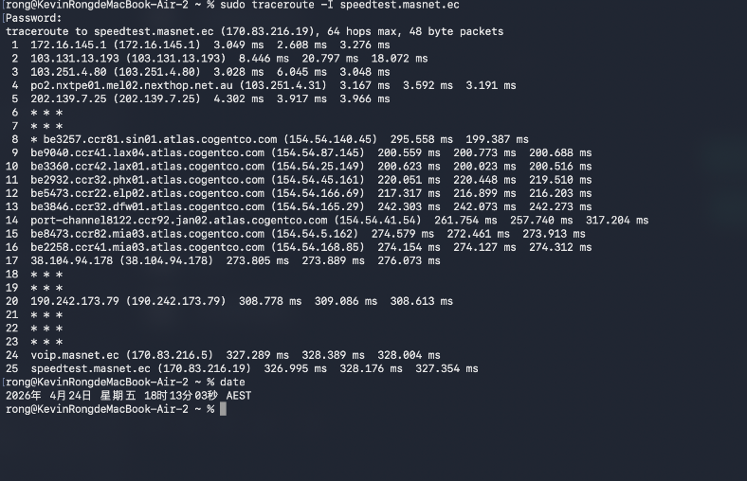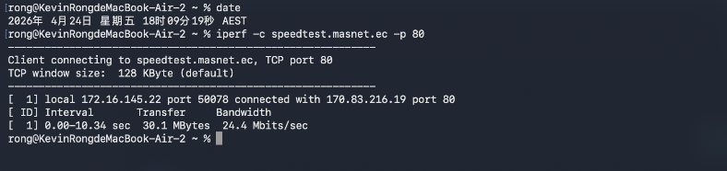
<4.2.1(c) Ecuador (Closest) – evening >
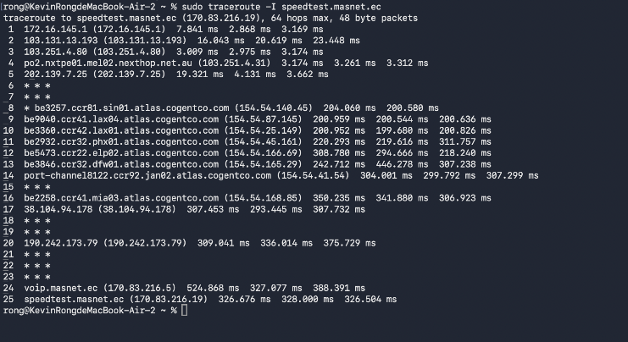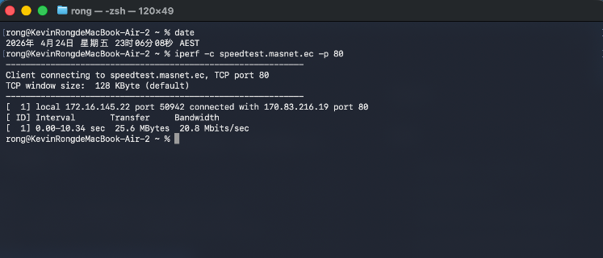

<4.2.1(d) Ecuador (Closest) – night >
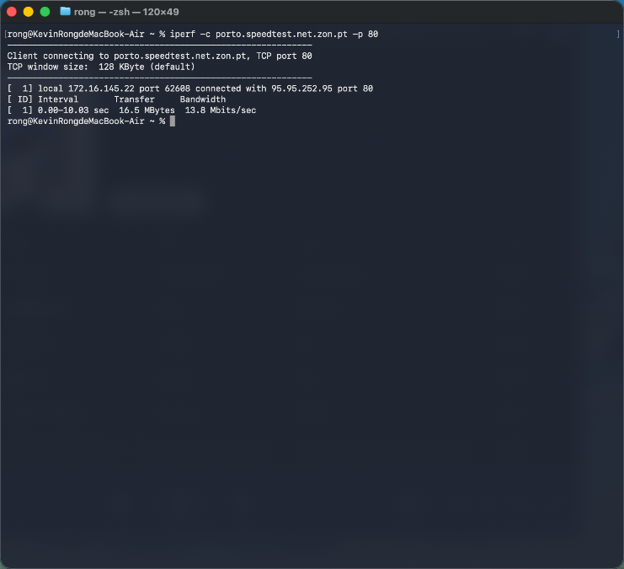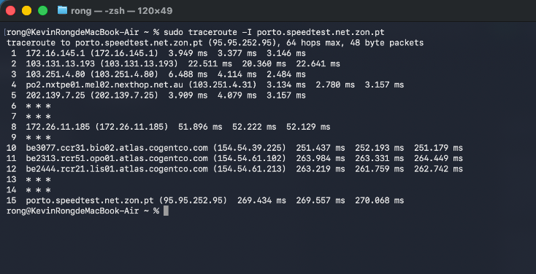
<4.2.2(a) Portugal (Furthest) – morning >
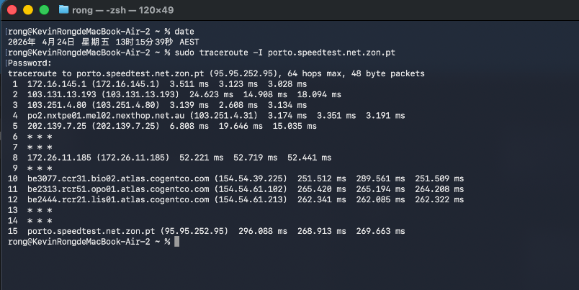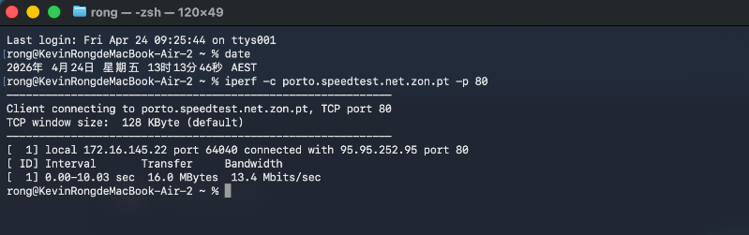

<4.2.2(b) Portugal (Furthest) – afternoon >
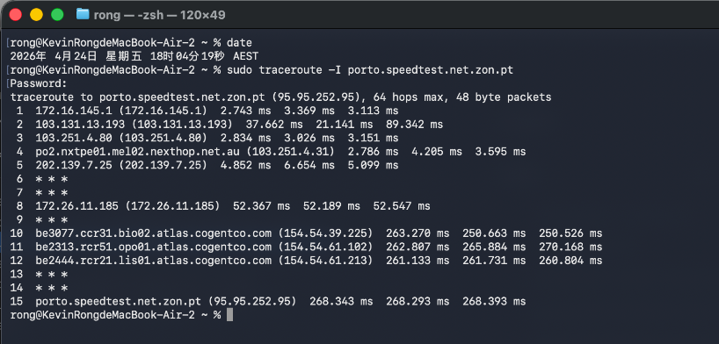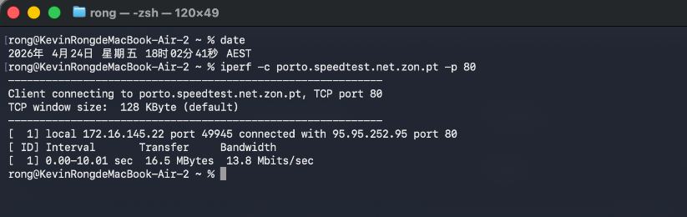
<4.2.2(c) Portugal (Furthest) – evening >
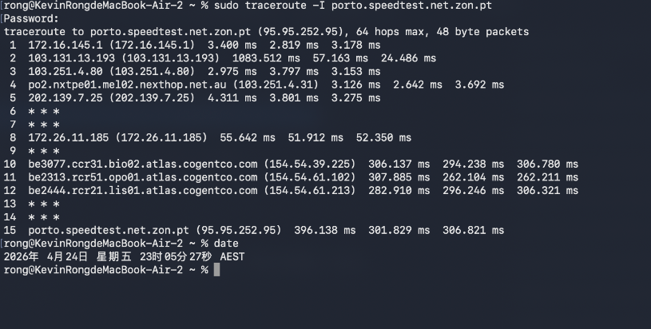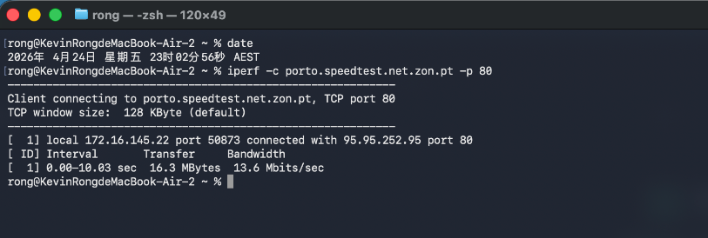
<4.2.2(d) Portugal (Furthest) – night >

